***Robustness Evaluation of LeTra Leaf Tracking under Image Degradations***

**Sumitra Shrestha**

**800788426**  
 ***Computer Science***  
 ***Southern Illionis University Edwardsville***  
 **Edwardsville, Illinois, USA**  
[**sumshre@siue.edu**](mailto:sumshre@siue.edu)

***Abstract*—** Accurate leaf segmentation and tracking are essential for high-throughput plant phenotyping; however, most models are developed and evaluated under ideal imaging conditions, limiting their applicability to real-world deployments. To address this gap, we investigate the robustness of the LeTra pipeline—a lightweight and recently proposed deep learning framework that combines Mask R-CNN segmentation with IoU-based identity tracking. While LeTra has demonstrated high performance using limited training data under clean conditions, its behavior under realistic visual degradations remains unknown. In this study, we systematically evaluate LeTra’s performance under three categories of synthetic degradation: Gaussian blur (3×3, 5×5, 7×7 kernels), salt and pepper noise (0.01, 0.025, 0.04 intensities), and brightness/contrast variation (0.7/0.8, 0.9/1.1, 1.3/1.2). Each configuration was applied to Arabidopsis thaliana rosette images from two datasets—one used purely for segmentation evaluation and the other for segmentation and identity tracking. On the segmentation dataset, brightness/contrast (0.9/1.1) yielded the best robustness, achieving an early-stage F1-score of 0.9701 and mean IoUs of 0.7305 (early), 0.8748 (mid), and 0.8611 (late). On the tracking dataset, segmentation under brightness/contrast (0.7/0.8) achieved an even higher F1-score of 0.9705 and mean IoU of 0.9546, while identity tracking produced a peak ID F1-score of 0.992 under the same condition—closely matching the results from clean images. The best-performing blur (3×3) and noise (0.01) settings also preserved strong performance but showed more degradation under harsher conditions. These findings demonstrate that LeTra maintains high segmentation and tracking accuracy under moderate image degradations—particularly brightness/contrast shifts—making it suitable for real-world phenotyping scenarios. Brightness/contrast adjustment emerges as a practical preprocessing step to enhance LeTra’s robustness in non-ideal imaging environments.

***Keywords—*** leaf segmentation, leaf tracking, image degradation, Mask R-CNN, IoU matching, plant phenotyping, Arabidopsis thaliana, deep learning.

# **I. Introduction**

High-throughput plant phenotyping has become a cornerstone in modern plant science, enabling researchers to monitor growth dynamics, assess genotypic differences, and evaluate environmental responses with precision and scale. Central to this effort is the ability to accurately segment and track individual leaves over time, a task complicated by challenges such as occlusion, leaf overlap, and varying lighting conditions. Among existing approaches [2], [3], [4], [5], [6], [7], [8], the LeTra pipeline stands out due to its lightweight design, accurate leaf instance segmentation, and minimal training requirements. Its demonstrated success in clean, top-down Arabidopsis thaliana imagery makes it an ideal candidate for testing robustness under real-world conditions, such as occlusion, overlapping leaves, and image degradation. LeTra combines Mask R-CNN for instance segmentation with IoU-based identity matching, offering a scalable solution for tracking multiple leaves over time. [1].

While LeTra has demonstrated high accuracy under controlled conditions, real-world imaging environments often introduce visual degradations—including blur from camera movement or focus issues, noise from sensor limitations, and lighting inconsistencies due to weather or field setup. These issues are echoed in broader phenotyping research, where methods such as Visual Growth Tracking [2] and Leaf Length Tracker [3] have reported the sensitivity of segmentation and tracking accuracy to imaging quality, environmental variability, and plant complexity.

Moreover, studies like those by [4] and [5] highlight how image-based leaf tracking pipelines, especially those relying on 2D features, can face reduced performance when leaves overlap or self-occlude—a problem worsened by degraded images. Similarly, model performance has been shown to decline under fluctuating lighting and noise conditions, as noted in multi-view phenotyping systems [6], and there remains a significant need for evaluating these models under practical field-like conditions.

To address these limitations, the current study presents a systematic evaluation of LeTra’s robustness under simulated image degradations. Specifically, we apply controlled levels of Gaussian blur, salt and pepper noise, and brightness/contrast variations to the original Arabidopsis dataset and assess the impact on segmentation and tracking performance across different plant developmental stages. Metrics such as mean Intersection-over-Union (IoU) and F-score are used to quantify performance loss or improvement under each degradation condition.

The goal is to assess the generalizability of LeTra across degraded imaging scenarios and identify which degradations affect the pipeline least. By doing so, we aim to inform the design of degradation-aware preprocessing strategies and encourage further adaptation of deep learning-based tools for field-ready plant phenotyping workflows.

# **II. Related Work**

This section reviews previous research on leaf segmentation and tracking in plant phenotyping, highlighting key algorithmic approaches and dataset developments. We first discuss classical feature-based methods, their limitations under complex imaging conditions, and how they evolved. Next, we examine recent deep learning-based models, including LeTra, focusing on their architecture, strengths, and existing gaps in robustness evaluation. Lastly, we present a comparative overview of widely used leaf datasets, underscoring their role in model development and the need for degradation-aware benchmarking.

Accurate and robust leaf segmentation and tracking are foundational to high-throughput plant phenotyping, as they enable measurement of essential traits such as growth rate, leaf area, rosette expansion, and photosynthetic efficiency. These tasks support automated monitoring in both controlled and field conditions. While segmentation identifies individual leaves in an image, tracking ensures consistent identification across time points. Over the past two decades, a wide range of algorithms have been developed, broadly categorized into feature-based and learning-based approaches. Both have evolved with advances in image processing, machine learning, and computational resources. However, a persistent limitation in the literature is the lack of evaluation under degraded imaging conditions—such as blur, noise, and lighting variability—which are common in real-world phenotyping environments. This study addresses that gap by rigorously evaluating the LeTra pipeline under controlled degradation scenarios [1].

**A. Feature-Based Methods**

Feature-based approaches were among the earliest and most widely adopted techniques in plant image analysis. These methods primarily rely on handcrafted features—manually designed heuristics that capture texture, edges, color distributions, or geometric shapes—to detect and segment plant structures. Although feature-based methods are computationally efficient and relatively easy to interpret, their reliance on fixed rules makes them vulnerable to background complexity, lighting variability, and structural variations in plants.

One of the most influential early works in this space was proposed by Yin et al. (2014), who developed a multi-leaf tracking method based on Chamfer Matching (CM). Their system utilized predefined leaf templates and aligned them frame-by-frame using gradient-based optimization in fluorescence videos of Arabidopsis thaliana. While Chamfer Matching was effective for consistent leaf shapes in later growth stages, the method suffered in the early growth phase, where leaf emergence and appearance rapidly evolve. Moreover, template rigidity made it difficult to adapt to changes in leaf orientation or growth-induced deformation, resulting in drift and identity mismatches over time [7]. To overcome some of these challenges, Yin et al. (2018) extended their approach into a joint segmentation-alignment-tracking framework, integrating all steps into a unified optimization problem. This resulted in better tracking of occluded leaves and moderate improvements in segmentation for overlapping rosettes. However, their method still relied on handcrafted shape priors and energy minimization, which limited scalability and robustness, especially under noisy or degraded imaging conditions [8].

Beyond Chamfer Matching, many traditional image processing pipelines have used morphological operations, watershed segmentation, superpixel clustering, and edge-based filtering. These include algorithms based on color thresholding in HSV or Lab space, active contours, or region-growing approaches. For example, Kumar and Domnic (2019) proposed a pipeline that enhances contrast using statistical normalization followed by Circular Hough Transform (CHT) to identify and count round leaves. While this method achieved good accuracy in controlled lab settings, it failed to generalize to leaves with irregular shapes or under variable lighting conditions commonly encountered in the field [10]. A comprehensive benchmark by Scharr et al. (2016) evaluated a wide range of these classical techniques on the CVPPP (Computer Vision Problems in Plant Phenotyping) dataset. The results showed that while some methods performed adequately on clean, high-resolution images, they consistently struggled with small or occluded leaves, dense rosettes, and non-uniform lighting—conditions that are frequently observed in practical plant imaging scenarios [9]. Although these feature-based approaches were foundational in advancing automated leaf analysis, their limitations in scalability, adaptability, and robustness—especially under image degradations—have prompted a shift toward deep learning-based techniques.

**B. Learning-Based Methods**

With the emergence of deep learning, particularly convolutional neural networks (CNNs), plant image analysis has undergone a paradigm shift. Unlike handcrafted techniques, deep learning models automatically learn features from data, allowing them to generalize across varying imaging conditions and plant morphologies—provided they are trained on diverse and sufficiently large datasets. Modern learning-based approaches have demonstrated superior accuracy and robustness, particularly in segmenting overlapping leaves and handling occlusions, noise, and background clutter. One of the most recent and effective learning-based frameworks for plant phenotyping is the LeTra pipeline proposed by Jurado-Ruiz et al. (2024). LeTra combines Mask R-CNN, a region-based instance segmentation model, with a simple yet effective Intersection-over-Union (IoU)-based leaf tracking mechanism. The segmentation component identifies individual leaf masks at each time point, while the IoU-based tracker matches corresponding leaves across frames by maximizing spatial overlap. This pipeline has achieved high segmentation and tracking accuracy on Arabidopsis thaliana images and is notable for its ability to operate with limited training data. LeTra’s modular design and strong baseline performance have made it a compelling option for phenotyping pipelines. However, despite its strengths, its robustness to real-world image degradations—such as motion blur, sensor noise, and variable lighting—remains insufficiently evaluated [1].

Several other deep learning models have tackled segmentation challenges using different architectures. Guo et al. introduced LeafMask, which integrates EfficientNet-B4 as a backbone with a modified UNet++ decoder. The model achieved a BestDice score of 90.09%, significantly outperforming traditional segmentation pipelines, especially in cases of complex leaf overlaps and varying lighting [11]. Similarly, Bhagat et al. (2022) proposed Eff-UNet++, which demonstrated high accuracy across multiple plant species. Their method incorporated attention modules to better capture spatial context and fine details, although performance degraded when tested on datasets with strong occlusions or low contrast [12]. To tackle the issue of limited annotated data, researchers like Ward et al. leveraged synthetic data generation. They simulated plant images with known leaf annotations to augment training datasets for Mask R-CNN, resulting in improved segmentation accuracy on real-world data. While synthetic augmentation improves generalization to unseen samples, it does not necessarily make models more resilient to low-quality inputs [13]. In addition, Yang et al. (2020) applied Mask R-CNN with a VGG16 backbone for classification and segmentation of plant leaves in natural environments. Their results confirmed the model’s ability to segment leaves in cluttered backgrounds, though it struggled with edge cases involving shadowed or partially occluded leaves [14]. For field deployment, Ngugi et al. (2020) developed KijaniNet, a lightweight segmentation model based on U-Net for use on mobile devices. Although designed for low-resource environments, the model’s accuracy declined sharply under image noise and inconsistent brightness levels, again highlighting the need for robust preprocessing or degradation-tolerant models [15].

Despite clear advancements in both feature-based and deep learning-based segmentation and tracking techniques, most existing studies evaluate performance under ideal or controlled imaging conditions. In real-world settings—such as greenhouse experiments, outdoor field trials, or low-cost camera setups—images are frequently affected by various forms of visual degradation, including Gaussian blur due to motion or defocus, salt and pepper noise from sensor inconsistencies, and brightness/contrast variation caused by natural lighting changes. These degradations can significantly impact model performance yet are rarely accounted for during model development or evaluation. This oversight represents a critical gap in literature. A model that performs well under pristine conditions but fails under minor degradations cannot be considered reliable for operational phenotyping pipelines. Therefore, understanding how and to what extent existing models can generalize to visually compromised input is vital for building truly deployable solutions. LeTra, a promising instance segmentation and tracking pipeline, has not yet been systematically evaluated for robustness against real-world visual degradations. This study addresses that gap by proposing such an evaluation [1].

**C. Existing Leaf Datasets**

The development of robust leaf segmentation and tracking models depends critically on the availability of diverse and well-annotated datasets. Over time, a number of datasets have been created to support various plant phenotyping objectives—from disease classification and leaf counting to longitudinal growth tracking and photosynthetic performance analysis. The Tomato Leaf Dataset [15] provides high-resolution RGB images collected under challenging environmental conditions and is tailored for healthy vs. diseased leaf classification. The CVPPP Leaf Segmentation Challenge datasets (A1–A5) [9] offer top-down images of Arabidopsis thaliana and Nicotiana tabacum, with pixel-level annotations and a wide range of phenotypic variations across time and lighting conditions. The Synthetic Leaf Dataset [13], generated using Blender, simulates realistic Arabidopsis rosettes with randomized traits, enabling scalable training of instance segmentation models without manual annotation effort. Indoor datasets such as KOMATSUNA and MSU-PID [4] focus on controlled-environment image capture, offering RGB-D and multi-modal imaging for deep learning tasks such as segmentation and classification. Meanwhile, the Eff-UNet++ subset of CVPPP [12] emphasizes occlusion and overlapping leaf challenges, serving as a benchmark for lightweight model evaluation. The LeTra dataset [1] contributes high-quality chlorophyll fluorescence imagery of Arabidopsis accessions under varying light treatments, annotated for both segmentation and tracking across growth stages. Finally, the UNL-CPPD [16] dataset offers multi-view, multi-modal imaging of maize plants in a high-throughput facility, with detailed structural annotations (e.g., leaf base, tip, collar) and XML-formatted ground truth, supporting complex phenotyping and component-based modeling. Table 1 provides a detailed comparison of these datasets, summarizing their properties, modalities, and application domains.

**Table 1. Comparative Summary of Existing Leaf Datasets**

|  |  |  |  |  |  |
| --- | --- | --- | --- | --- | --- |
| **Dataset** | **Species / Type** | **Modality** | **Size / Resolution** | **Annotations** | **Key Features** |
| Tomato Leaf Dataset | Tomato / Real | RGB | 1,408 images, 160×200 to 3888×2592 | Manual (MATLAB Segmenter) | Daylight/night capture, blur, cluttered background, 68× augmentation |
| CVPPP A1–A5 | Arabidopsis, Tobacco / Real | RGB | A1–A5: ~1,300 images, up to 3108×2324 | Semi-auto / Pixel-level | Benchmark challenge dataset, occlusion, irrigation reflections, time-series |
| Synthetic Leaf Dataset | Arabidopsis (3D model) / Synthetic | RGB | 30,000 synthetic images | Procedural (Blender pipeline) | Simulated rosettes, randomized textures, Gaussian blur, COCO textures |
| KOMATSUNA | Komatsuna / Real | RGB, RGB-D | 900 images, 480×480 | Public tool | Indoor RGB-D images, controlled lighting, growth modeling |
| MSU-PID | Arabidopsis, Bean / Real | RGB, IR, Depth | 576 images, ~116×119 | Manual (MATLAB GUI) | Multi-modal, multi-day Arabidopsis and Bean imaging |
| CVPPP (Eff-UNet++ Subset) | Arabidopsis, Tobacco / Real | RGB | 810 images, 512×512 | Semi-auto segmentation | Occluded and overlapping leaves, benchmark for lightweight models |
| LeTra | Arabidopsis / Real | Chlorophyll Fluorescence (CF) | 149 train, 53 val, 204 tracked leaves | Manual pixel-wise | PSII efficiency phenotyping, tracked CF images, light treatments |
| UNL-CPPD | Maize / Real | RGB, IR, NIR, Fluor, Hyperspectral | ~702 images, 2 views × 27 days | XML + Image (LabelMe) | Multi-view and multi-modal maize data, detailed leaf structure in XML |

Among these datasets, the LeTra dataset was selected for this study due to its unique combination of chlorophyll fluorescence imagery, detailed manual annotations, and longitudinal tracking across growth stages. Unlike other datasets that focus solely on segmentation or classification, LeTra provides temporally consistent leaf identities under varied lighting conditions—making it ideally suited for evaluating robustness to visual degradation in both segmentation and tracking tasks [1].

# **III.** **Methodology**

**A. Proposed Methodology**

The proposed methodology is structured into several key components, each contributing to a robust evaluation of leaf segmentation and tracking performance under degraded image conditions using the LeTra pipeline.

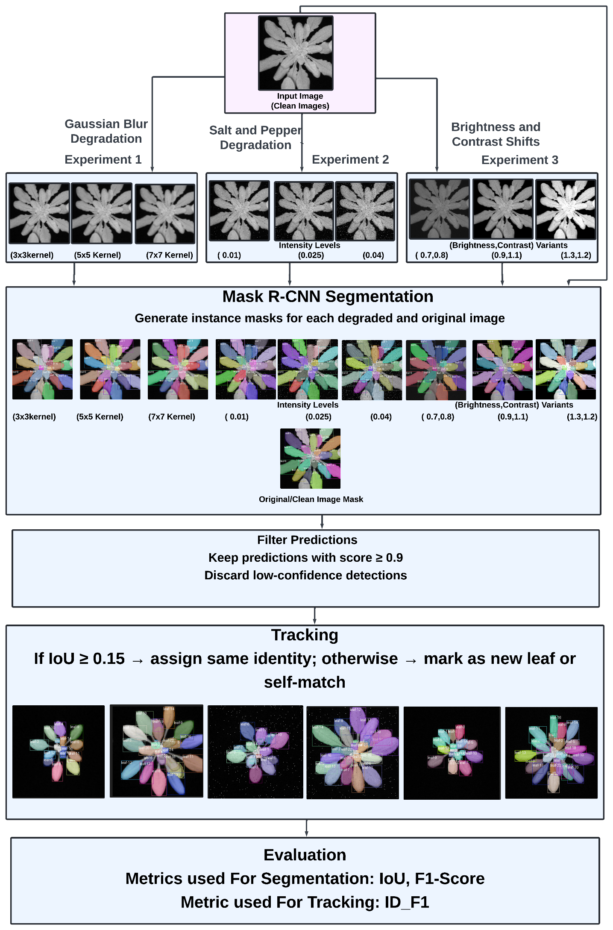

**Figure 1.** Simplified block diagram showing the LeTra evaluation pipeline, including preprocessing (image degradation), segmentation via Mask R-CNN, identity tracking with IoU matching, and final performance evaluation.

We evaluated the robustness of the LeTra leaf tracking model using a held-out validation dataset of top-down RGB images of Arabidopsis thaliana. These images were captured at three distinct growth stages (early, mid, and late development), providing a broad representation of leaf appearances over time. Notably, no further training or fine-tuning was performed on the LeTra model for this experiment; instead, we employed a pre-trained instance of the model directly in inference mode. LeTra is a Mask R-CNN-based pipeline for leaf instance segmentation and tracking​. This approach isolates the effects of image quality on model performance without introducing confounding factors from additional training adjustments.

**1. Input Original Images:** The workflow begins with top-down RGB images of Arabidopsis thaliana plants captured at three distinct developmental stages—Early, Mid, and Late. These images serve as the baseline input for both clean and degraded processing paths. The growth stages are critical to understanding model behavior across varying morphological complexity.

**2. Image Degradations:** To evaluate the robustness of the LeTra leaf tracking model under varying image quality conditions, we introduced three types of synthetic image degradations to the original validation dataset: Gaussian blur, salt & pepper noise, and brightness/contrast shifts. These degradations were designed to simulate real-world imaging challenges such as motion blur, sensor noise, and inconsistent lighting conditions.

**I. Gaussian Blur:** Gaussian blur was used to simulate defocus and motion-induced distortions. We implemented this using OpenCV’s built-in cv2.GaussianBlur() function inside a custom Python function apply_gaussian_blur(img, ksize=3). The kernel size (ksize) controls the level of blurring; we applied three variants using 3×3, 5×5, and 7×7 kernels. Each image from the validation set was read using cv2.imread(), blurred using the specified kernel, and saved using cv2.imwrite() to separate directories (e.g., Degraded_Blur_3x3/).

**II. Salt and Pepper Noise:** To mimic sensor and compression artifacts, we added salt & pepper noise at three intensity levels: 0.01, 0.025, and 0.04. This was implemented using a custom function add_salt_pepper_noise(image, prob) which randomly sets a proportion of pixels to white ([255, 255, 255]) and black ([0, 0, 0]) based on the given probability. The noise was added to each image in the validation set by iterating with tqdm, and the output was saved in separate folders such as Degraded_SaltPepper_003/. This simulates pixel corruption typically observed in compressed or low-light images.

**III. Brightness and Contrast Shifts:** To simulate natural variations in illumination, brightness and contrast were modified using a custom function adjust_brightness_contrast(image, brightness=1.0, contrast=1.0). The function adjusts brightness by multiplying the pixel values and modifies contrast by scaling the difference from the mean. We created three transformation variants with parameters: (0.7, 0.8), (0.9, 1.1), and (1.3, 1.2), representing darker, normal, and brighter conditions. These transformations were applied across all validation images, and the outputs were saved in respective directories (Degraded_BrightnessContrast_1/, etc.).

By applying these degradations consistently across the validation dataset using reproducible Python scripts, we ensured a controlled environment for analyzing the impact of image quality on leaf segmentation and tracking performance. This step is critical for understanding how robust the LeTra pipeline remains under suboptimal imaging conditions typically encountered in real-world plant phenotyping setups. Each type of degradation was applied independently to the images – meaning that blur, noise, and brightness/contrast adjustments were not combined with one another. This yielded a series of degraded image sets covering a range of common quality issues (out-of-focus blur, sensor noise, and illumination changes) that are known to adversely affect feature extraction in vision models. We then ran the pre-trained LeTra model on every degraded image variant as well as on the original (clean) validation images. For each image, the model produced predicted leaf segmentations and associated leaf identities from its tracking mechanism. These predictions were compared against the ground-truth annotations of each leaf in the image to quantify the model’s performance under each condition.

**3. Mask R-CNN Segmentation:** A fine-tuned Mask R-CNN model was used for instance segmentation. The model architecture utilized a ResNet-50 backbone pretrained on MS COCO. Only the classification and mask heads were fine-tuned using the leaf training dataset. Key hyperparameters included a learning rate of 0.005, momentum of 0.9, and a learning rate decay factor (gamma) of 0.1 every 3 epochs (step_size=3). The model was trained for 10 epochs using the SGD optimizer with a weight decay of 0.0005. The goal was to segment each individual leaf in both clean and degraded images.

**4. Filter Predictions:** After inference, only high-confidence predictions were retained for further evaluation. A threshold of 0.9 was set on the confidence score of predicted masks. Predictions below this threshold were discarded to minimize false positives and ensure robust evaluation, especially important under noisy or distorted conditions.

**5. Tracking:** The tracking step linked segmented leaves across sequential time points using Intersection over Union (IoU)-based matching. If the IoU between a leaf mask at time step t and its counterpart at t+1 was ≥ 0.15, the masks were considered to represent the same leaf and were assigned a consistent ID. Otherwise, the new mask was labeled as either a new leaf or a self-match. This simple but effective rule-based method enables longitudinal tracking without requiring complex temporal models.

**6. Evaluation:** For each degradation setting and stage (Early, Mid, Late), segmentation and tracking performance were quantitatively assessed. Metrics included Intersection over Union (IoU) for segmentation accuracy, Precision, Recall, and F1-Score for detection performance.

**7. Analysis & Recommendations:** Finally, performance trends across all experiments were analyzed. The results helped identify which degradations had the most detrimental impact on the model and provided insight into the model’s tolerance thresholds. For example, high-intensity salt and pepper noise was more disruptive than mild blur, while moderate brightness shifts were well-tolerated. These insights inform preprocessing strategies, model design improvements, and practical deployment recommendations in real-world plant phenotyping platforms.

**B. Metrics**

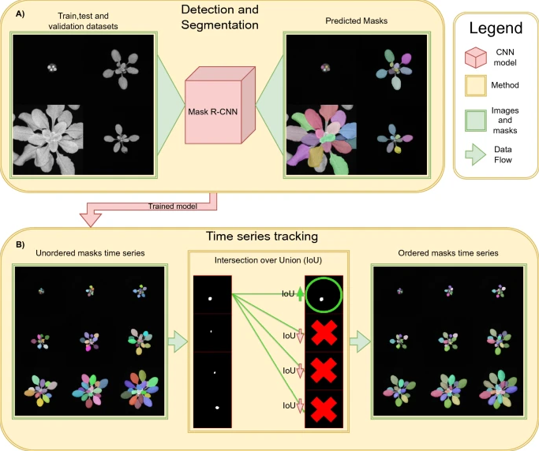

**Figure 2.** LeTra Pipeline: The proposed approach involves two stages: (A) training a segmentation model on A. thaliana images, and (B) using it to segment time-series images. Masks are matched across time steps based on IoU to enable accurate leaf tracking.

Following the LeTra tracking pipeline, we computed two complementary evaluation metrics: Intersection over Union (IoU) and F1-score. IoU measures the overlap between the predicted leaf mask and the true leaf region, defined as the area of intersection divided by the area of union between the predicted and ground-truth segmentation. The F1-score (the harmonic mean of precision and recall) was used to assess the model’s accuracy in detecting and identifying leaves, reflecting how well the model balances false positives and false negatives in leaf detection. Together, these metrics provide a view of both the quality of leaf segmentation (IoU) and the effectiveness of leaf instance detection/tracking (F1) for each image.

**1. Intersection over Union (IoU):** The IoU metric measures the degree of overlap between the predicted segmentation mask and the ground truth mask. It is defined as:

$$IoU=\frac{\left|\operatorname{Pr}{e}diction∩GroundTruth\right|}{\left|\operatorname{Pr}{e}diction∪GroundTruth\right|}$$

**2. Precision and Recall**

$$\operatorname{Pr}{e}cision=\frac{TruePositives\left(TP\right)}{TruePositives\left(TP\right)+FalsePositives\left(FP\right)}​$$

$$Recall=\frac{TruePositives\left(TP\right)}{TruePositives\left(TP\right)+FalseNegatives\left(FN\right)​}$$

**3. F1-Score:** The F1-Score combines precision and recall using their Harmonic Mean. It is particularly useful in evaluating performance under class imbalance or incomplete detections:

$$F1-Score=2*\frac{\operatorname{Pr}{e}cision * Recall}{\operatorname{Pr}{e}cision + Recall}​$$

**4. Identification F1-Score (ID F1):** ID F1-score is used to evaluate how well the model maintains leaf identities over time, a crucial aspect of tracking. It combines the accuracy of detection and temporal identity assignment. A high ID F1 indicates not only accurate frame-by-frame detection but also consistency in assigning the same ID to the same leaf across multiple timepoints. This is particularly important in longitudinal phenotyping, where tracking growth or photosynthetic traits per leaf is needed.

$ID F1 Score=\frac{2*ID\operatorname{Pr}{e}cision*IDRecall}{ID\operatorname{Pr}{e}cision+IDRecall}$

Where:

ID Precision and ID Recall measure correct identity associations compared to the ground truth tracking labels. It penalizes identity switches, fragmentations, or missed assignments, making it ideal for evaluating robust leaf tracking performance.

For each degradation type, we analyzed the model’s performance across the range of severity levels to determine which setting was least harmful to the model’s accuracy. In other words, within each category (blur, noise, brightness/contrast), we identified the specific degradation level that yielded the highest IoU, ID_F1-score and F1-score on average. For example, the smallest Gaussian blur kernel and the lowest noise density generally led to the best results (as these represent the mildest distortions), whereas an intermediate brightness/contrast adjustment might prove optimal if extreme darkening or over-brightening degrades performance.

After selecting these top-performing settings for each degradation category, we then compared them to determine the overall “best of all” degraded scenario. This overall best-case degradation result – the single set of degraded images on which LeTra performed the strongest – was finally compared against the model’s performance on the original, non-degraded validation and tracking dataset. By examining the IoU, ID_F1-score and F1 obtained in this optimal degraded condition relative to those on clean images, we could quantify the model’s robustness in more practical terms. This final comparison reveals the extent of performance drop under the least detrimental degradation, highlighting how much accuracy is sacrificed even under favorable degradation settings versus ideal image conditions. All steps were carried out using consistent evaluation protocols to ensure a fair robustness assessment across the different image degradation scenarios.

# **C. Dataset**

This study employed a comprehensive dataset of Arabidopsis thaliana images to train, validate, and evaluate the LeTra leaf tracking model. The dataset was structured into three main components:​

Training and Testing Dataset for Detection and Segmentation: The primary dataset comprised 166 individual plant images, encompassing a total of 1,773 leaves. These images captured plants at various developmental stages, ranging from the emergence of the first true leaves to day 26 after sowing. Of these, 149 images were allocated for training, and 17 images were reserved for testing the Mask R-CNN model, ensuring a robust framework for leaf detection and segmentation [1]. ​

Validation Dataset: An independent validation dataset was utilized to assess the model's performance across different growth phases. This dataset consisted of 53 images representing 18 individual plants, categorized into three developmental stages:​

Early Stage: 16 images (one image was removed due to the absence of visible leaves), Mid Stage: 18 images, Late Stage: 18 images.​ This stratification allowed for a comprehensive evaluation of the model's generalizability across various growth stages. By employing these well-structured datasets, we ensured a rigorous evaluation of the LeTra pipeline's capabilities in leaf detection, segmentation, and tracking across various developmental stages of Arabidopsis thaliana.

Tracking Dataset: Additionally, a dedicated Tracking Evaluation Dataset was used to assess LeTra’s identity tracking performance. This dataset consisted of time-series images of 9 plants (slots A1–C3), each of size 266×266 pixels, observed over 57 consecutive time points. In total, 204 leaves were annotated and tracked. Importantly, this dataset was not used during the training or validation of the segmentation model; it served exclusively to evaluate tracking robustness across time and under degradation conditions.

**Visual and Quantitative Representation of Growth Stages**

The figure below presents representative top-down grayscale images from the validation dataset across the three developmental stages. These images not only vary visually but also reflect the increasing difficulty in segmentation and tracking due to the number of leaves, their spatial distribution, and degree of occlusion.

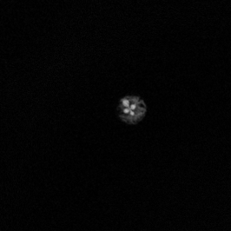 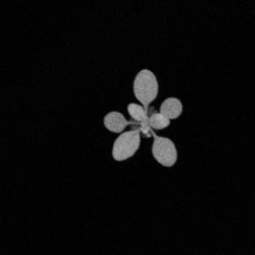 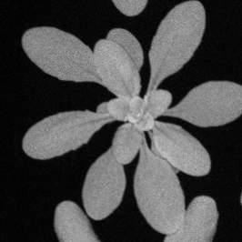 a) Early Stage (b) Mid Stage (c) Late Stage

**Figure 3.** Representative validation dataset images of *Arabidopsis thaliana* plants at different growth stages.

As the plant matures, the number of leaves increases, and the spatial complexity of the rosette structure presents greater challenges for accurate segmentation and identity-preserving tracking.

The validation dataset includes representative images from three distinct growth stages of Arabidopsis thaliana, each capturing unique morphological characteristics that contribute to varying levels of segmentation difficulty. At the early stage, the rosette consists of 4–6 small, rounded, and well-separated leaves. Due to their high contrast against the background and minimal occlusion, segmentation at this stage poses a relatively low challenge. The mid-stage image presents a moderately developed rosette with 10–15 leaves. The leaves vary in size and orientation, and moderate overlap is observed near the center of the plant. This stage introduces a medium level of complexity for segmentation, as boundaries between adjacent leaves become less distinct. In the late stage, the rosette is fully developed with 20 or more leaves. These leaves are larger and significantly overlap, forming a dense, compact canopy. This high degree of occlusion, along with varied leaf morphologies, presents substantial challenges for accurate segmentation and identity tracking [1]. These images reflect a gradual increase in complexity, providing a robust basis for evaluating the LeTra model’s ability to generalize and perform under different developmental conditions.

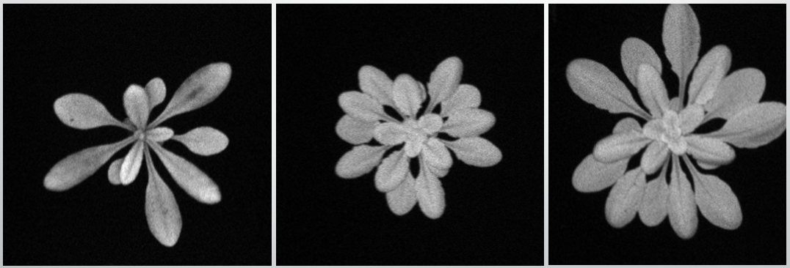

**Figure 4.** Representative tracking dataset images of *Arabidopsis thaliana* plants at different growth stages.

Figure above displays representative tracking dataset images of different *Arabidopsis thaliana* plants captured at varying growth stages. Each image corresponds to a distinct plant rather than sequential time points of a single specimen. These top-down grayscale images reflect morphological diversity across early, mid, and late developmental stages, with increasing leaf number, size, and overlap from left to right. The dataset serves as the foundation for evaluating the LeTra model’s leaf identity tracking capabilities, where each plant instance presents unique structural challenges. This diversity ensures robust assessment of the model’s generalization and tracking performance across a range of plant architectures.

# **VI. Experiment Design**

This section presents a comprehensive experimental framework designed to evaluate the robustness of the LeTra leaf segmentation and tracking model under various image degradation conditions. The primary objective is to investigate how different types and intensities of image degradation impact the model's detection accuracy, measured by F1-score, and segmentation quality, measured by Intersection over Union (IoU), across different plant growth stages.

Three forms of degradation were introduced to simulate realistic imaging challenges. Gaussian blur, with kernel sizes of 3, 5×5, and 7×7, was used to simulate motion blur and loss of focus. Salt and pepper noise was applied at intensities of 0.01, 0.025, and 0.04 to mimic pixel-level corruption due to sensor noise. Brightness and contrast were also varied independently as brightness/contrast adjustments (0.7/0.8, 0.9/1.1, 1.3/1.2) to reflect fluctuating lighting conditions during image capture. Each type of degradation was applied separately to isolate its impact on model performance.

The experimental pipeline began with a clean, high-resolution dataset consisting of top-down images of Arabidopsis plants. Each image sequence was independently degraded using one of the selected parameters. The pretrained LeTra model was then used to perform leaf instance segmentation and IoU-based tracking on each degraded dataset. The outputs were compared to ground truth annotations using an IoU threshold of 0.15 to determine true positives (TP), false positives (FP), and false negatives (FN). Based on these values, F1-scores and mean IoUs were calculated for each noise condition and growth stage.

For each degradation type, the intensity level that yielded the best performance in terms of both F1-score and IoU was identified. These per-type best settings were then synthesized to determine the overall optimal degradation setting. Finally, the performance under this optimal degraded condition was compared with results from the original, undegraded dataset to benchmark the model’s generalization capability. The ultimate goal of this experiment is to determine which degradation conditions minimally impact performance, thereby revealing the model’s robustness in real-world scenarios.

To structure the evaluation, five key experimental setups were designed and implemented:

* **Experiment 1– Gaussian Blur Comparison:** Comparing the effects of Gaussian blur using three kernel sizes (3×3, 5×5, 7×7) to determine how defocus impacts model robustness. Identifying the best-performing kernel that yields the highest segmentation, detection and tracking scores.
* **Experiment 2– Salt & Pepper Noise Comparison:** Comparing different intensities of salt and pepper noise (0.01, 0.025, 0.04) to evaluate the impact of pixel-level corruption on segmentation and detection performance. Identifying the best-performing intensity that maintains the highest F1-score, ID F1-scores and IoU across all growth stages.
* **Experiment 3– Brightness/Contrast Comparison:** Comparing brightness/contrast adjustments using three settings: (0.7/0.8), (0.9/1.1), and (1.3/1.2), representing low to high lighting variability. Identifying the most resilient brightness/contrast combination based on F1-score, ID F1-scores and IoU.

**Best Degradation Type Overall:**

This aimed to identify which type of image degradation—Gaussian blur, salt & pepper noise, or brightness/contrast adjustment—was most robust against performance loss in the LeTra pipeline. From each degradation category, the top-performing configuration was selected based on the highest observed Intersection over Union (IoU), ID F1-score and F1-score. Specifically, we compared Gaussian Blur (3×3), Salt & Pepper Noise (0.01), and Brightness/Contrast Adjustment (0.9/1.1), each of which had previously demonstrated minimal impact on segmentation and tracking accuracy.

By evaluating these “best of each type” settings under consistent validation protocols, we determined which degradation type led to the least reduction in detection and segmentation quality compared to clean images. This allowed us to conclude not only which configuration was most favorable within each category, but also which type of degradation overall posed the least threat to model robustness

**Clean vs. Best Degradation Comparison:** This compares the model’s performance on the clean validation dataset with its performance under the best-performing degradation type—brightness/contrast adjustment (0.9, 1.1). The goal is to quantify how much accuracy is retained under mild visual distortions, providing insight into the model’s real-world robustness.

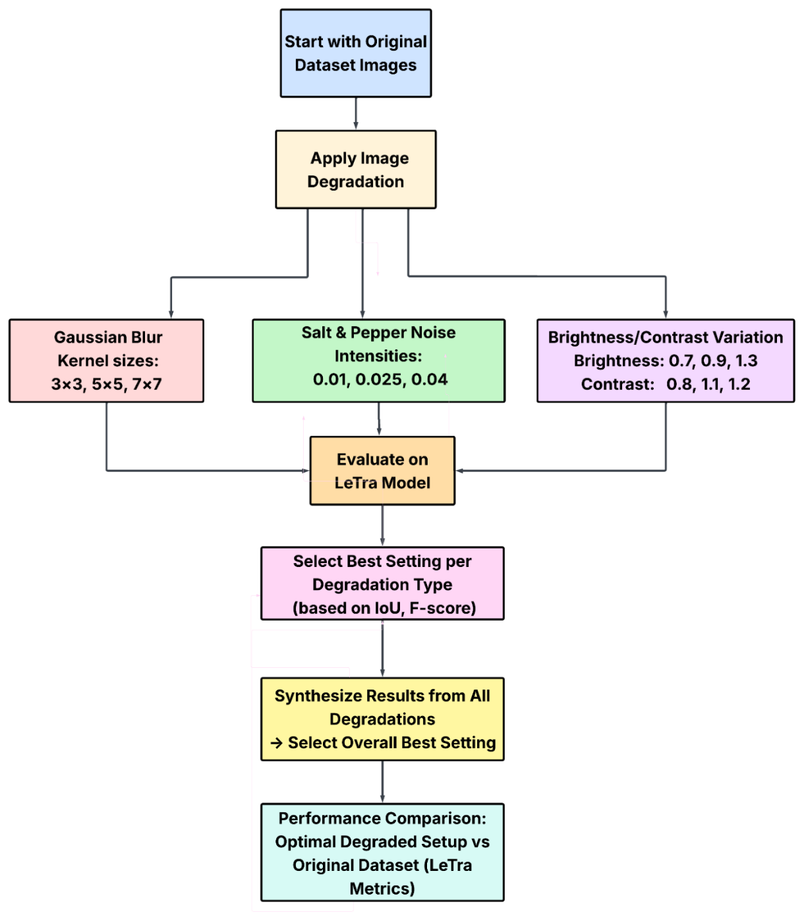  
**Figure 5.** Workflow for evaluating LeTra’s robustness across image degradations and comparing optimal degradation type to original data.

This design offers a structured and quantitative approach to assess and compare model resilience across a range of image perturbations.

# **VII. Results**

This section presents the results of all five experiments outlined in the Experiment Design section. The aim was to evaluate the LeTra model’s robustness under different image degradation conditions. The model was tested on various intensities and types of degradation, and its performance was measured using two standard metrics: F1-score for detection accuracy, mean Intersection over Union (IoU) for segmentation accuracy and ID F1-score for the tracking accuracy. All evaluations were conducted for tracking dataset while only F1-score and IOU were evaluated across three distinct growth stages: Early, Mid, and Late, for segmentation dataset.

**A. Validation Dataset**

**Experiment 1 – Gaussian Blur Comparison**

The performance of the LeTra leaf segmentation and tracking model was evaluated under three levels of Gaussian blur to simulate an increasing defocus: 3×3, 5×5, and 7×7 kernel sizes. These tests were conducted across three plant growth stages—Early, Mid, and Late—to assess the model’s robustness over different developmental conditions. For each degraded image, LeTra predicted individual leaf segmentations and tracked their identities across time, and these predictions were compared against ground truth annotations using mean Intersection over Union (IoU) and F1-score.

**Table 2.** F1-scores and IoU values of the LeTra model under three Gaussian blur kernel sizes (3×3, 5×5, 7×7) across Early, Mid, and Late plant growth stages.

|  |  |  |  |  |  |  |
| --- | --- | --- | --- | --- | --- | --- |
| **Stage** | **IoU Mean - Blur 3x3** | **F1 Score - Blur 3x3** | **IoU Mean - Blur 5x5** | **F1 Score - Blur 5x5** | **IoU Mean - Blur 7x7** | **F1 Score - Blur 7x7** |
| Early | 0.7285 | 0.9624 | 0.7271 | 0.9697 | 0.7102 | 0.9538 |
| Mid | 0.8732 | 0.9597 | 0.8796 | 0.9524 | 0.8815 | 0.9441 |
| Late | 0.8566 | 0.9323 | 0.854 | 0.9286 | 0.8542 | 0.9246 |

Among the three blur levels, the 3×3 kernel consistently resulted in the highest performance, achieving F1-scores of 0.962, 0.960, and 0.932 for the Early, Mid, and Late stages, respectively. The corresponding mean IoU values were also strong at 0.728, 0.873, and 0.857. The 5×5 kernel showed slightly lower results with F1-scores of 0.970 (Early), 0.952 (Mid), and 0.929 (Late), and IoUs of 0.727, 0.880, and 0.854. Although the differences were marginal, the trend showed a consistent decrease in performance as blur intensity increased. With the 7×7 kernel, the model exhibited the lowest F1-scores across all stages—0.954 (Early), 0.944 (Mid), and 0.925 (Late)—and a further decline in mean IoU, especially in the Early stage, which dropped to 0.710. This drop suggests that smaller and less distinct leaf structures in early development are more vulnerable to degradation caused by blur.

Interestingly, Mid-stage images yielded the highest segmentation accuracy across all blur levels, indicating that moderate leaf expansion and clearer spacing provided favorable conditions for LeTra’s detection and tracking pipeline. In contrast, Early-stage performance was more sensitive to blur, with notable degradation in segmentation quality as kernel size increased. Despite this, F1-scores remained relatively robust compared to IoU, showing that the model maintained its ability to detect the correct number of leaves and track them over time, even when segmentation boundaries were less precise.

Overall, the Gaussian blur experiment revealed that the LeTra model is fairly resilient to mild blur conditions. The best results were obtained under the 3×3 kernel setting, which provided the most accurate leaf segmentation and tracking across all growth stages. However, as blur intensified, both IoU and F1-score declined gradually, highlighting the importance of image sharpness in high-throughput phenotyping applications. These findings demonstrate that while LeTra performs well under moderate degradation, preserving image clarity remains essential for optimal tracking and analysis.

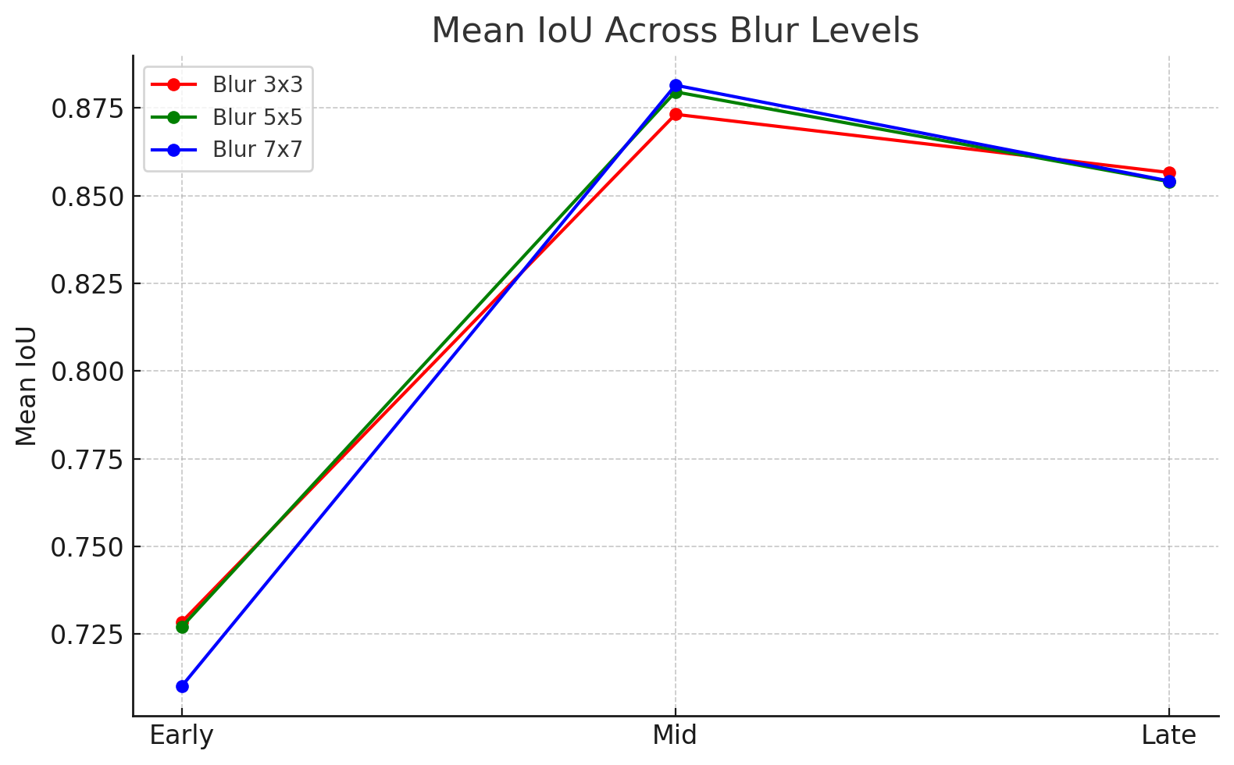

**Figure 6.** Mean IoU Across Blur Levels

Figure above presents the mean Intersection over Union (IoU) across early, mid, and late growth stages under three levels of Gaussian blur: 3×3, 5×5, and 7×7 kernels. Overall, mid-stage images consistently yielded the highest IoU across all blur levels, indicating that the model performs best when leaf sizes and separation are optimal. While the early stage saw noticeable IoU reductions due to small and poorly defined leaves, late-stage performance slightly declined likely due to occlusions and dense leaf clustering. Among the blur variants, the 3×3 kernel performed best overall, especially in early-stage conditions, suggesting it introduces the least degradation. This highlights that mild blurring has minimal impact on segmentation, whereas stronger blur (7×7) can slightly hinder detection, particularly in early-stage images.

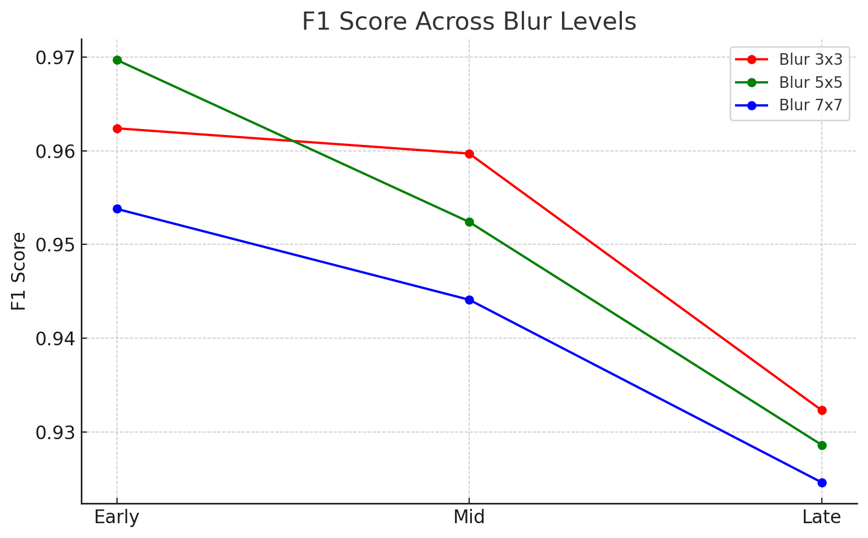

**Figure 7.** F1 Score Across Blur Levels

Figure above illustrates how the F1 Score varies across growth stages under different levels of Gaussian blur. Notably, all blur configurations show a decline in F1 Score from early to late stages, reflecting increasing difficulty in accurate leaf detection as occlusions and leaf overlaps become more prominent. The 3×3 blur kernel consistently outperformed the 5×5 and 7×7 kernels, particularly in mid and late stages, demonstrating greater resilience to minor blurring. In contrast, the 7×7 kernel led to the steepest decline in F1 Score, especially at the late stage, where leaf boundaries become less distinct. These results suggest that while the model tolerates mild blur reasonably well, excessive blurring substantially impacts its detection precision and recall.

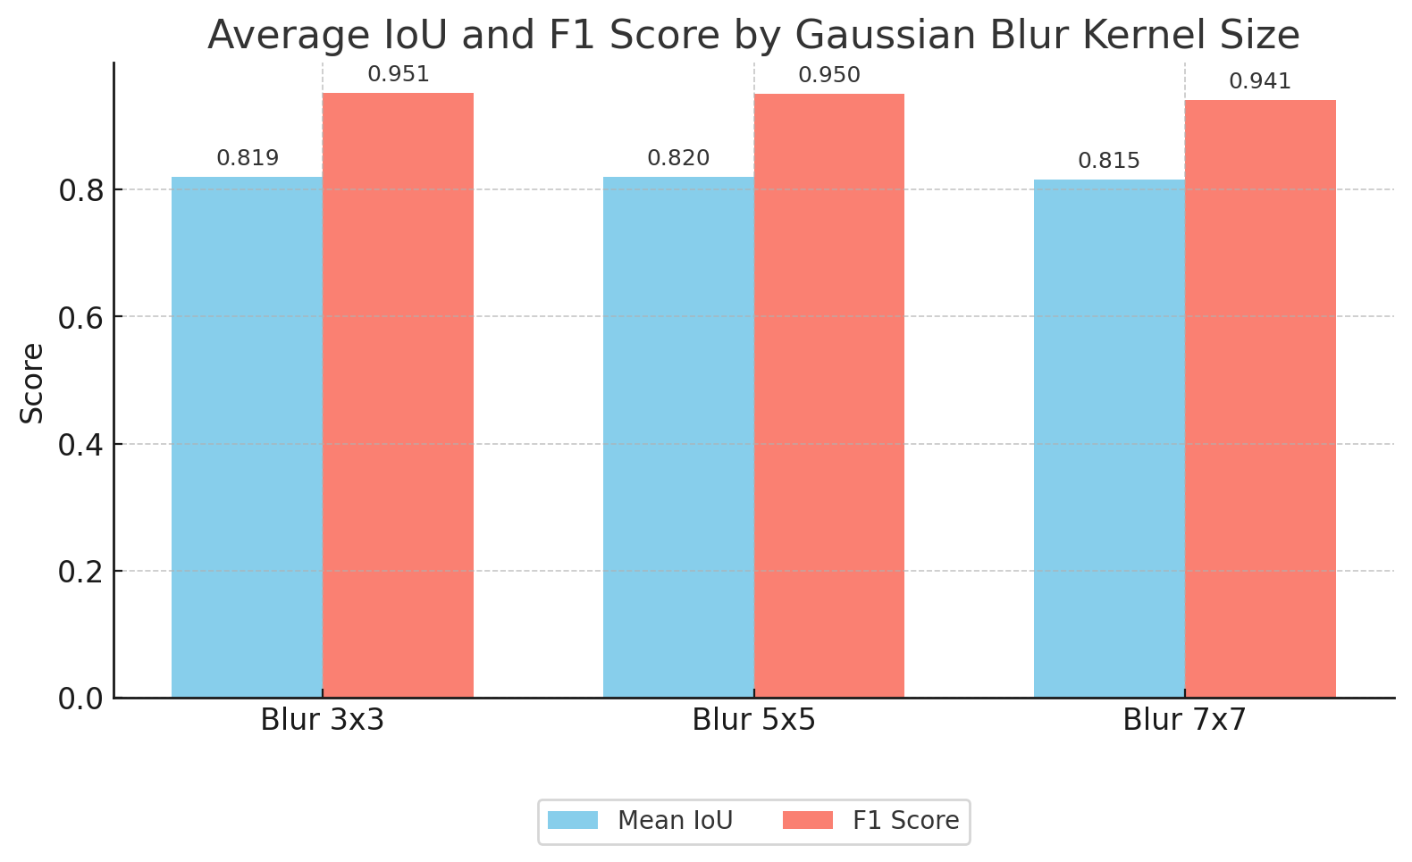**Figure 8.**  Average IoU and F1 Score by Gaussian Blur Kernel Size

This chart illustrates how the LeTra model performs under different levels of Gaussian blur, using kernel sizes 3×3, 5×5, and 7×7. Blur simulates out-of-focus images, which can obscure leaf edges and boundaries. Blur 3×3 yielded the best overall detection and segmentation results (IoU: 0.819, F1: 0.951). Blur 5×5 caused a minor drop in IoU (0.820) but maintained high detection accuracy (F1: 0.950). Blur 7×7 saw a larger impact on segmentation (IoU: 0.815) and a slight drop in F1 (0.941), reflecting increasing blur severity. LeTra maintains robust performance under mild blur but shows progressive degradation as blur intensifies.

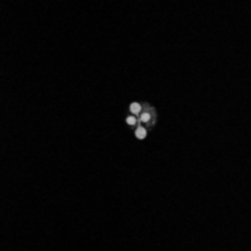 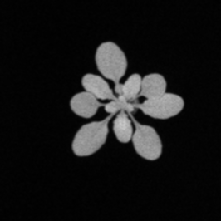 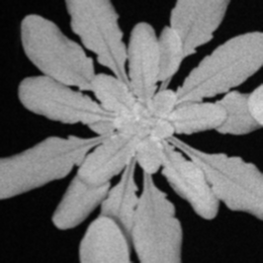(a) Early Stage (b) Mid Stage (c) Late Stage

**Figure 9.** Gaussian Blur (Kernel Size: 3×3)

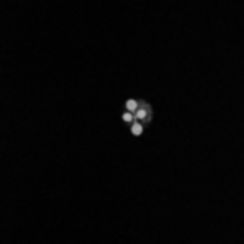 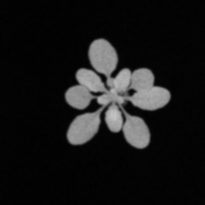 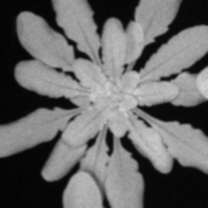

(a) Early Stage (b) Mid Stage (c) Late Stage

**Figure 10.** Gaussian Blur (Kernel Size: 5×5)

 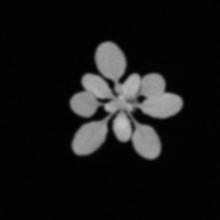 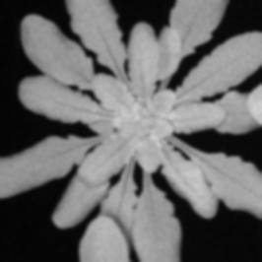(a) Early Stage (b) Mid Stage (c) Late Stage

**Figure 11.** Gaussian Blur (Kernel Size: 7×7)

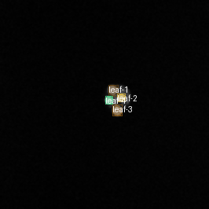 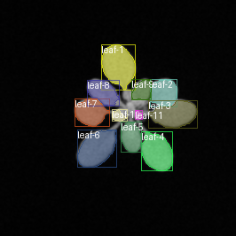 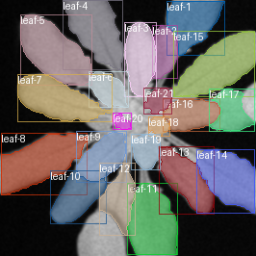

(a) Early Stage (b) Mid Stage (c) Late Stage

**Figure 12.** Leaf Tracking Output with 3×3 Blur

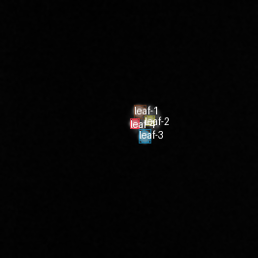 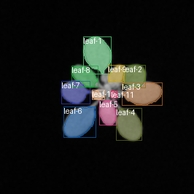 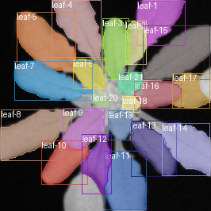

(a) Early Stage (b) Mid Stage (c) Late Stage

**Figure 13.** Leaf Tracking Output with 5×5 Blur

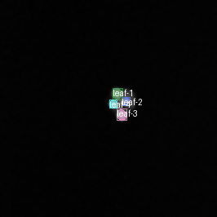 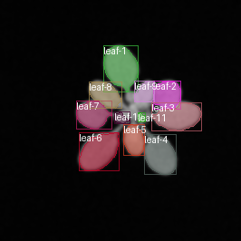 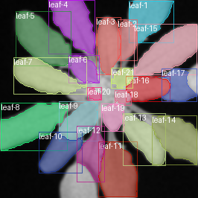

(a) Early Stage (b) Mid Stage (c) Late Stage

**Figure 14.** Leaf Tracking Output with 7×7 Blur

**Experiment 2 – Salt & Pepper Noise Comparison**

The robustness of the LeTra model was further evaluated under varying levels of salt and pepper noise, introduced at noise densities of 0.01, 0.025, and 0.04. These intensities simulate increasing levels of sensor noise and impulse artifacts, where random pixels are corrupted by black-and-white values. The model’s performance was assessed across Early, Mid, and Late growth stages using mean Intersection over Union (IoU) for segmentation accuracy and F1-score for detection and tracking reliability.

**Table 3.** F1-scores and IoU values for the LeTra model under Salt & Pepper noise at intensities 0.01, 0.025, and 0.04 across all growth stages.

|  |  |  |  |  |  |  |
| --- | --- | --- | --- | --- | --- | --- |
| **Stage** | **IoU Mean - SP 0.01** | **F1 Score - SP 0.01** | **IoU Mean - SP 0.025** | **F1 Score - SP 0.025** | **IoU Mean - SP 0.04** | **F1 Score - SP 0.04** |
| Early | 0.7175 | 0.9697 | 0.7111 | 0.9375 | 0.7125 | 0.8475 |
| Mid | 0.8733 | 0.9492 | 0.8727 | 0.9444 | 0.8792 | 0.8938 |
| Late | 0.8624 | 0.9112 | 0.8148 | 0.8607 | 0.7541 | 0.7713 |

At the lowest noise density (0.01), the model demonstrated strong performance, achieving high F1-scores of 0.970, 0.949, and 0.911 across Early, Mid, and Late stages, respectively. The corresponding mean IoU scores were 0.717, 0.873, and 0.862, indicating effective segmentation even with minor noise corruption. As the noise level increased to 0.025, a moderate decline in performance was observed. F1-scores dropped slightly to 0.938 (Early), 0.944 (Mid), and 0.861 (Late), and IoUs declined to 0.711, 0.873, and 0.815, respectively. The impact was most evident in the Late stage, where denser foliage made accurate segmentation more challenging under noise-induced distortion.

At the highest noise level (0.04), the model exhibited a more substantial performance degradation, particularly in the Late stage. The F1-score fell to 0.847 for Early, 0.894 for Mid, and just 0.771 for Late, while the mean IoU dropped to 0.713, 0.879, and 0.754, respectively. This suggests that excessive noise interferes with both segmentation precision and the model’s ability to consistently track individual leaves over time. Notably, the recall values dropped sharply, especially in the Late stage, indicating a significant increase in false negatives as more leaves were missed by the model.

Across all three intensity levels, the Mid-stage images consistently yielded the highest segmentation and detection accuracy, reinforcing prior observations that moderately developed rosettes are most suitable for reliable tracking. Early-stage performance remained relatively stable under light and moderate noise but declined more under high noise. Late-stage performance proved the most vulnerable to salt and pepper artifacts, with both segmentation and detection metrics showing the sharpest decline.

In summary, the LeTra pipeline remained robust under low levels of salt and pepper noise, with only minor performance loss at 0.01 noise density. However, as the corruption level increased to 0.025 and 0.04, the model’s accuracy decreased, especially in dense canopy conditions. These findings highlight the model’s sensitivity to impulse noise and emphasize the importance of denoising or quality control steps in image acquisition pipelines to ensure high-throughput phenotyping accuracy.

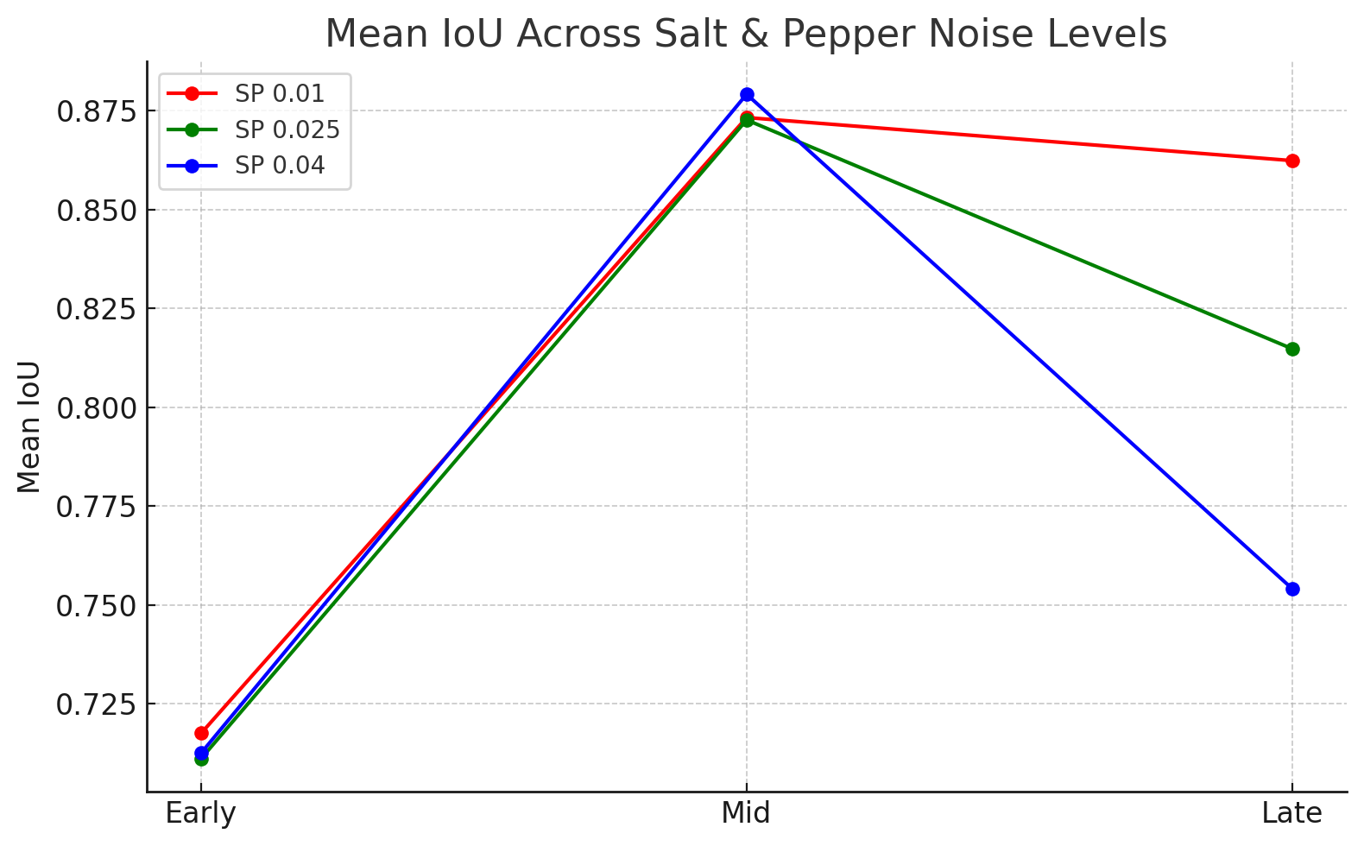

**Figure 15.** Mean IoU Across Salt & Pepper Noise Levels

Figure above presents the effect of increasing salt & pepper noise levels (0.01, 0.025, 0.04) on segmentation quality as measured by Intersection over Union (IoU) across growth stages. All three noise intensities show a consistent pattern: performance peaks at the mid stage and declines sharply at the late stage, where increased leaf overlap and occlusion challenge accurate mask generation. Among the tested noise intensities, the 0.01 setting (the mildest) yields the highest IoU across all stages, indicating minimal interference with the model’s segmentation ability. In contrast, the 0.04 noise level significantly reduces IoU in the late stage, highlighting the vulnerability of the model to higher noise densities. These findings suggest that the model can tolerate low levels of impulsive noise, but segmentation accuracy deteriorates rapidly with more aggressive distortions.

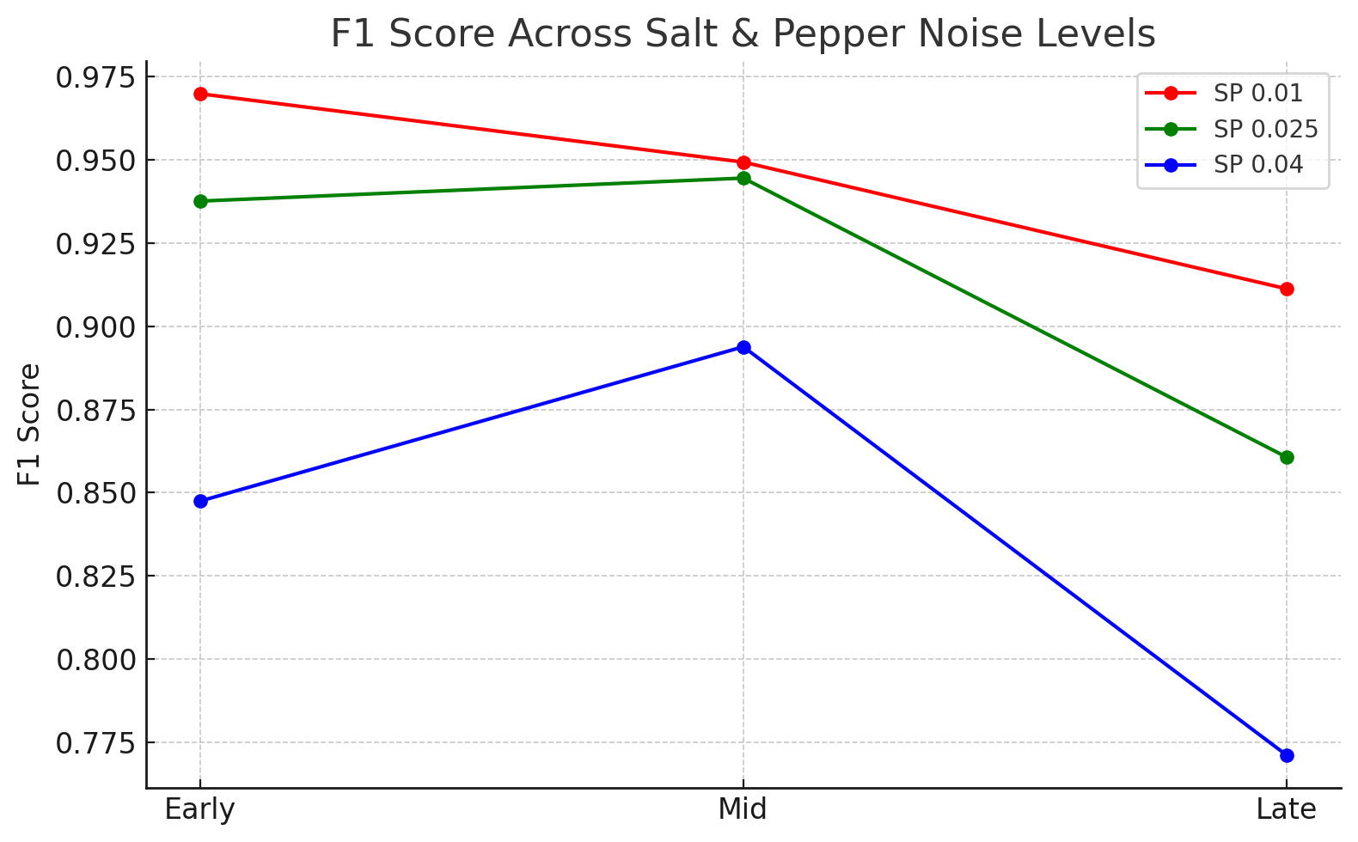

**Figure 16.** F1 Score Across Salt & Pepper Noise Levels

Figure above evaluates the impact of varying salt & pepper noise intensities on the model’s detection and tracking ability, reflected by the F1-score. The results show that mild noise (0.01) consistently delivers the highest F1-scores across all growth stages, affirming the model’s resilience to light impulsive noise. However, as noise intensity increases to 0.025 and 0.04, the F1-score drops sharply—particularly at the late stage—indicating that higher noise levels not only obscure leaf boundaries but also introduce false positives and missed detections. The lowest F1-score (under 0.78) is observed for SP 0.04 at the late stage, suggesting that this setting significantly degrades the model's ability to correctly detect and associate leaf instances. Overall, these results emphasize that the LeTra model’s robustness to salt & pepper noise diminishes rapidly beyond minimal distortion levels.

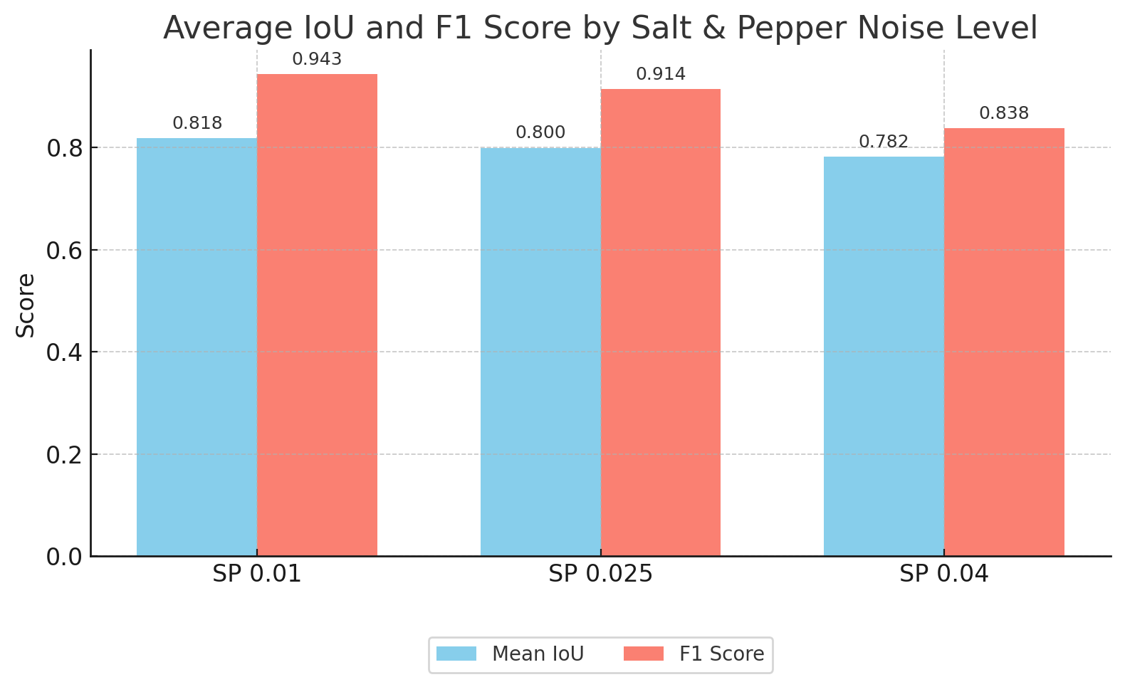

**Figure 17.** Average IoU and F1 Score by Salt & Pepper Noise Level

This chart compares the average IoU and F1 Score across three salt-and-pepper noise intensities: 0.01, 0.025, and 0.04. As noise intensity increases, both metrics decline, reflecting the model’s reduced ability to accurately detect and segment leaves in the presence of random pixel corruption. SP 0.01 achieved the best results with an IoU of 0.818 and an F1 score of 0.943, indicating minimal degradation. SP 0.025 shows a slight drop, especially in segmentation quality (IoU: 0.800, F1: 0.914). SP 0.04 caused the most impact, reducing IoU to 0.782 and F1 score to 0.838, emphasizing the model’s sensitivity to high-intensity impulse noise. LeTra is robust under light salt-and-pepper noise but performance decreases as noise density increases.

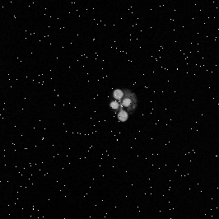 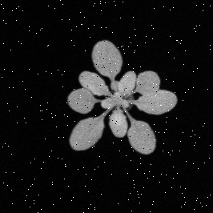 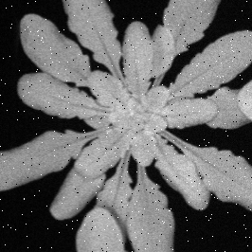(a) Early Stage (b) Mid Stage (c) Late Stage

**Figure 18.** Salt & Pepper Noise (Intensity: 0.01)

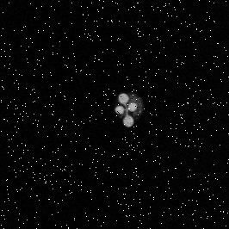 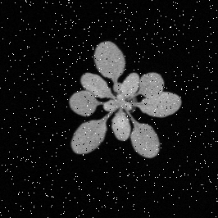 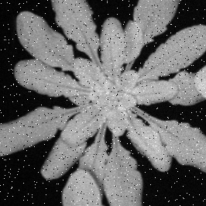 (a) Early Stage (b) Mid Stage (c) Late Stage

**Figure 19.** Salt & Pepper Noise (Intensity: 0.025)

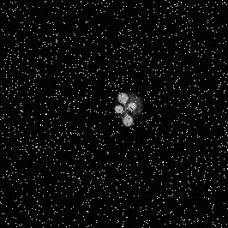 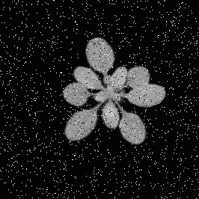 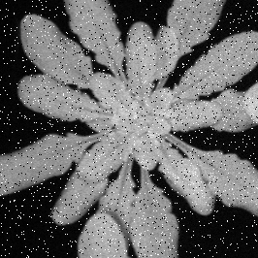

(a) Early Stage (b) Mid Stage (c) Late Stage

**Figure 20.** Salt & Pepper Noise (Intensity: 0.04)

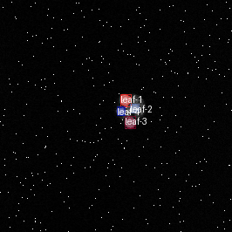 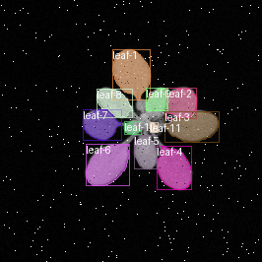 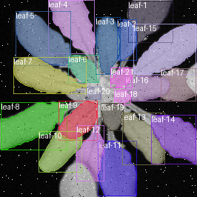

(a) Early Stage (b) Mid Stage (c) Late Stage

**Figure 21.** Leaf Tracking Output with Salt & Pepper Noise Level 0.01

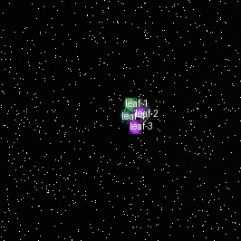 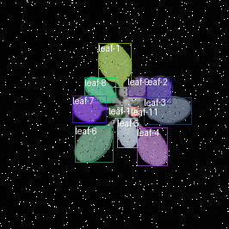 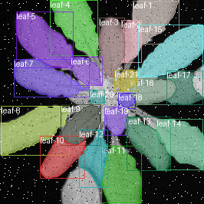

(a) Early Stage (b) Mid Stage (c) Late Stage

**Figure 22.** Leaf Tracking Output with Salt & Pepper Noise Level 0.025

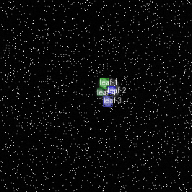 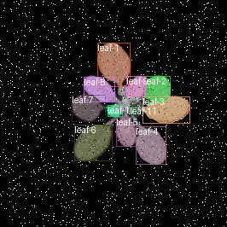 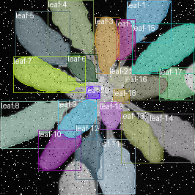

(a) Early Stage (b) Mid Stage (c) Late Stage

**Figure 23.** Leaf Tracking Output with Salt & Pepper Noise Level 0.04

**Experiment 3 – Brightness/Contrast Comparison**

To assess the LeTra model’s sensitivity to varying illumination conditions, we applied three combinations of brightness and contrast adjustments to the validation images: (0.7, 0.8), (0.9, 1.1), and (1.3, 1.2). These adjustments simulate darker, balanced, and brighter imaging environments, respectively. The model’s segmentation and tracking performance was evaluated using Intersection over Union (IoU) and F1-score across three plant growth stages.

**Table 4.** Comparison of F1-scores and IoU values for three brightness/contrast settings— (0.7, 0.8), (0.9, 1.1), and (1.3, 1.2)—across Early, Mid, and Late stages.

|  |  |  |  |  |  |  |
| --- | --- | --- | --- | --- | --- | --- |
| **Stage** | **IoU Mean - BC 0.7/0.8** | **F1 Score - BC 0.7/0.8** | **IoU Mean - BC 0.9/1.1** | **F1 Score - BC 0.9/1.1** | **IoU Mean - BC 1.3/1.2** | **F1 Score - BC 1.3/1.2** |
| Early | 0.7346 | 0.9624 | 0.7305 | 0.9701 | 0.7288 | 0.9701 |
| Mid | 0.877 | 0.9559 | 0.8748 | 0.9568 | 0.8856 | 0.9639 |
| Late | 0.8581 | 0.934 | 0.8611 | 0.9421 | 0.8767 | 0.9275 |

The (0.9, 1.1) setting—representing a slight darkening with enhanced contrast—resulted in the highest overall detection performance, with F1-scores of 0.970 (Early), 0.957 (Mid), and 0.942 (Late). Mean IoU values for this setting were also solid, at 0.730, 0.875, and 0.861 across the three stages. The brightest setting (1.3, 1.2) yielded the highest segmentation quality in Mid and Late stages, with IoU scores of 0.886 and 0.877, and F1-scores of 0.964 and 0.928, respectively. Early-stage scores remained consistent, with F1 at 0.970 and IoU around 0.729, showing the model’s general robustness to brightness increases.

Interestingly, the darkest setting (0.7, 0.8) led to slightly reduced F1-scores, especially in the Late stage (0.934), but remained competitive with IoUs of 0.735 (Early), 0.877 (Mid), and 0.858 (Late). Across all three variants, the Mid stage consistently yielded the highest IoU values, likely due to favorable leaf spacing and contrast at this developmental phase.

Overall, these results demonstrate that the LeTra model is relatively resilient to brightness and contrast variations. Moderate enhancements in contrast (0.9, 1.1 or 1.3, 1.2) slightly improve both segmentation and tracking accuracy, while excessive darkening (0.7, 0.8) introduces a modest performance drop. These findings highlight the model’s robustness to illumination differences and suggest that pre-processing adjustments can help maintain high segmentation quality under fluctuating lighting conditions.

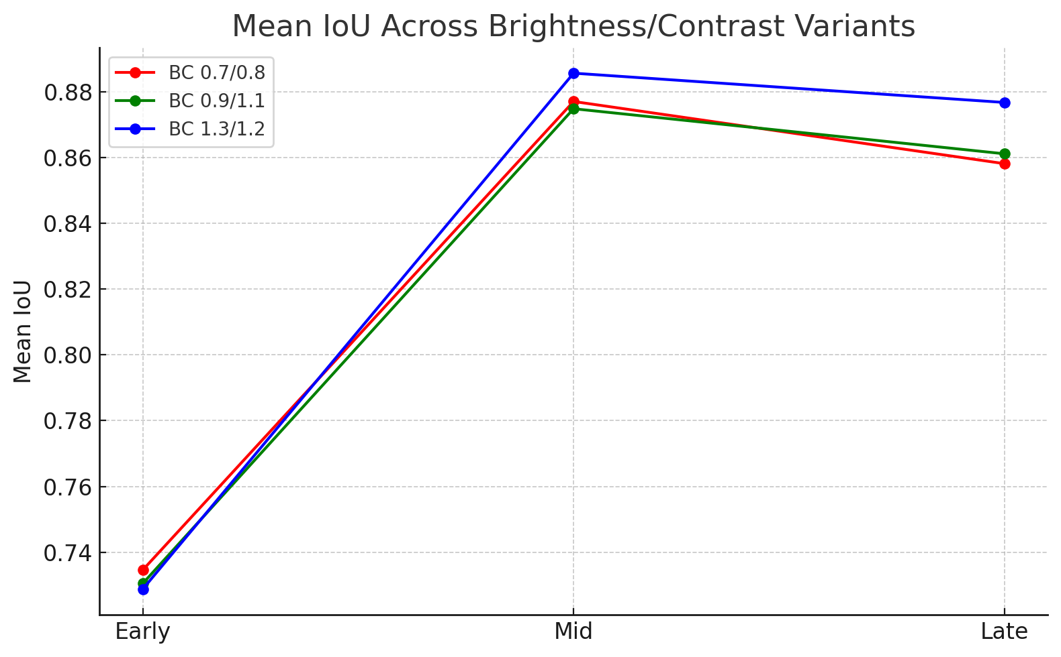

**Figure 24.** Mean IoU Across Brightness/Contrast Variants

Figure above compares the segmentation accuracy of the LeTra model under three brightness/contrast (BC) transformations. The results demonstrate that all variants achieved relatively high Intersection-over-Union (IoU) scores across the growth stages, with the BC 1.3/1.2 setting consistently outperforming the others. This configuration yielded the highest IoU, particularly during the mid and late stages, suggesting that a moderate increase in brightness and contrast enhances leaf boundary visibility. In contrast, the lower contrast setting (BC 0.7/0.8) showed a slight reduction in IoU, especially in early-stage plants where leaf features are less defined. Despite the visual stress introduced by lighting changes, all configurations maintained IoU above 0.85 in later stages, indicating the model’s general robustness. These findings suggest that brightness/contrast variations—especially modest enhancements—can improve segmentation quality without significantly hindering the model's performance.

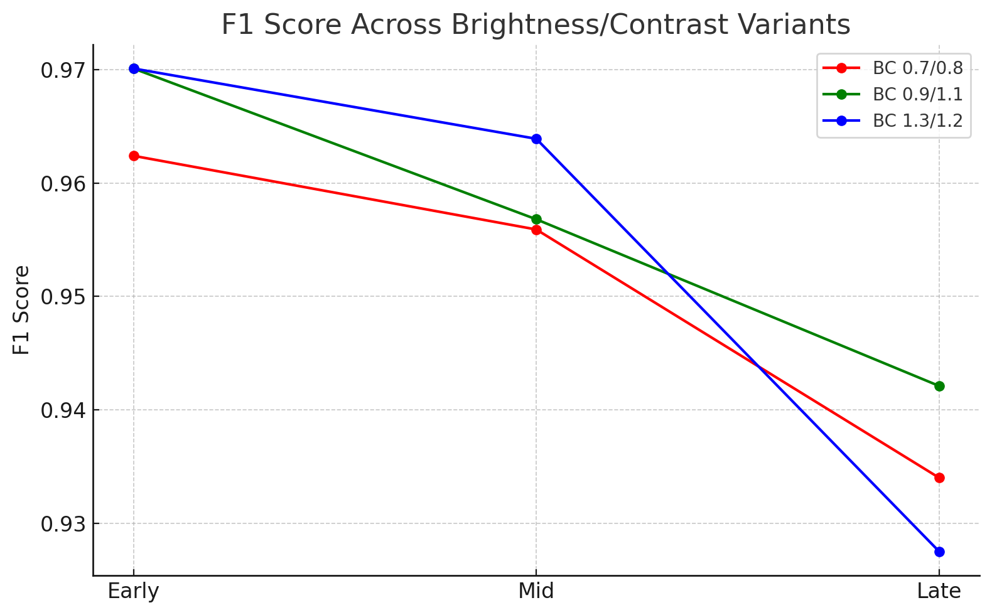

**Figure 25.** F1 Score Across Brightness/Contrast Variants

Figure above illustrates how varying brightness and contrast levels affect the model’s leaf detection and tracking ability, as reflected by F1-scores. Interestingly, the BC 1.3/1.2 configuration, which previously delivered the highest IoU, exhibited a steeper performance drop in late-stage images, resulting in the lowest F1-score among the three settings. This suggests that while high contrast may aid segmentation, it could lead to more false positives or inconsistencies in detection, particularly in densely overlapping late-stage leaves. The BC 0.9/1.1 setting yielded the most stable F1 performance across stages, indicating a balanced trade-off between visibility enhancement and detection reliability. In contrast, the BC 0.7/0.8 setting performed slightly worse overall but remained relatively consistent. These results emphasize that while brightness/contrast augmentations can improve segmentation alignment, overly aggressive enhancements may disrupt instance-level accuracy, especially in complex plant structures.

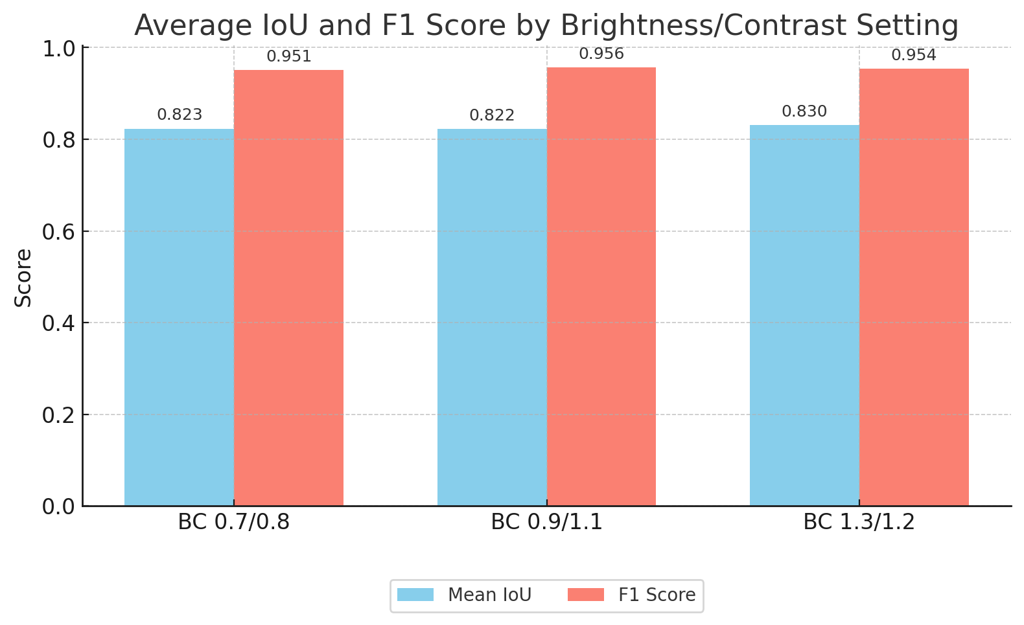

**Figure 26.** Average IoU and F1 Score by Brightness/Contrast Setting

This chart compares the LeTra model’s average IoU and F1 Score under three different brightness and contrast adjustment settings:(0.7, 0.8) — darker with lower contrast, (0.9, 1.1) — moderate brightness with enhanced contrast, (1.3, 1.2) — brighter with stronger contrast. BC 0.9/1.1 produced the best overall performance, with an F1 Score of 0.956 and IoU of 0.822, suggesting that slightly increased contrast and moderate brightness improve both detection and segmentation. BC 1.3/1.2 maintained a strong F1 Score (0.954) and the highest IoU (0.830), indicating effective segmentation under brighter conditions. BC 0.7/0.8 had the lowest IoU (0.823) and F1 (0.951) among the three but still performed competitively, showing resilience even under darkened images. LeTra is robust under various lighting conditions, with optimal performance at moderate brightness and contrast (0.9, 1.1). Extreme brightness or dimming leads to slight accuracy shifts but does not significantly degrade results.

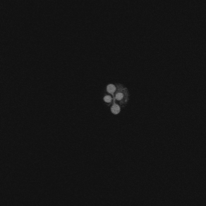 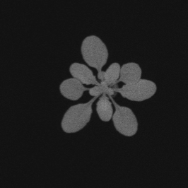 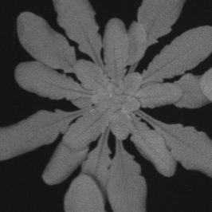

(a) Early Stage (b) Mid Stage (c) Late Stage

**Figure 27.** Brightness/Contrast Adjustment (0.7 / 0.8)

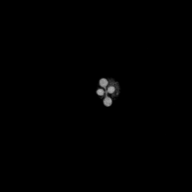 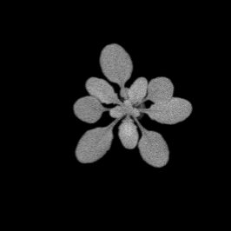 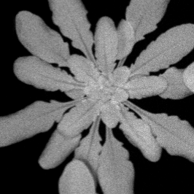

(a) Early Stage (b) Mid Stage (c) Late Stage

**Figure 28.** Brightness/Contrast Adjustment (0.9 / 1.1)

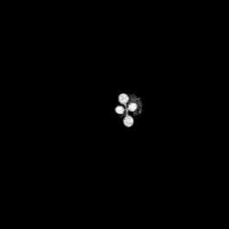 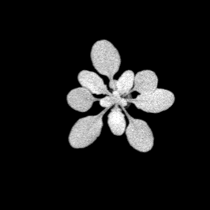 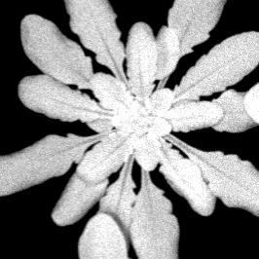

(a) Early Stage (b) Mid Stage (c) Late Stage

**Figure 29.** Brightness/Contrast Adjustment (1.3 / 1.2)

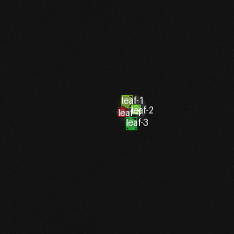 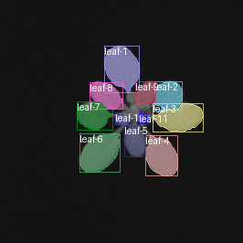 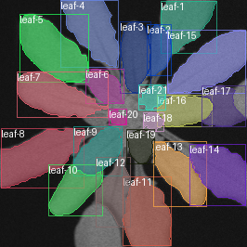

(a) Early Stage (b) Mid Stage (c) Late Stage

**Figure 30.** Leaf Tracking Output with Brightness/Contrast Adjustment (0.7 / 0.8)

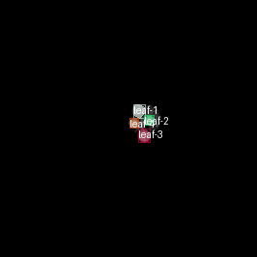 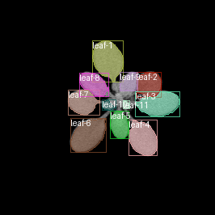 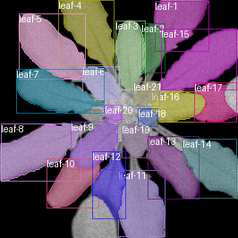

(a) Early Stage (b) Mid Stage (c) Late Stage

**Figure 31.** Leaf Tracking Output with Brightness/Contrast Adjustment (0.9 / 1.1)

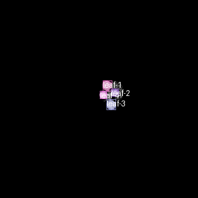 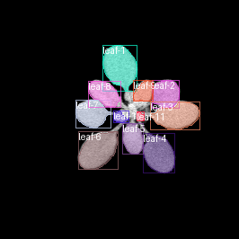 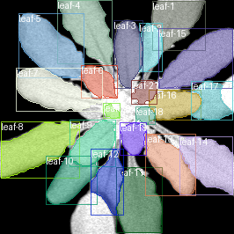

(a) Early Stage (b) Mid Stage (c) Late Stage

**Figure 32.** Leaf Tracking Output with Brightness/Contrast Adjustment (1.3 / 1.2)

**Best Degradation Type Overall**

In this final experiment, we compared the best-performing configurations from each degradation category—Gaussian blur, salt and pepper noise, and brightness/contrast adjustment—to identify which distortion type the LeTra model handles most robustly. The selected configurations were Gaussian blur with a 3×3 kernel, salt and pepper noise at a density of 0.01, and brightness/contrast adjustment with values of (0.9, 1.1). Each of these was previously shown to yield the highest average Intersection over Union (IoU) and F1-score within its category across the Early, Mid, and Late plant growth stages.

Table 5 and 6 presents a direct comparison of the average IoU and F1-scores across all three best-case degradation types. Among them, the brightness/contrast setting (0.9, 1.1) consistently outperformed the others, achieving the highest overall F1-score (0.956) and a strong mean IoU of 0.822. This indicates that moderate enhancements in lighting and contrast not only preserve, but may slightly improve, the model’s ability to segment and track leaves across growth stages.

Gaussian blur with a 3×3 kernel followed closely, delivering an average F1-score of 0.951 and IoU of 0.819, showing that LeTra is resilient to mild image defocus. The performance declined only slightly compared to brightness/contrast adjustments, emphasizing the model’s robustness under low blur conditions. Meanwhile, salt and pepper noise at a low density of 0.01 also maintained competitive results, with a mean F1-score of 0.943 and IoU of 0.818. Although the degradation was minimal, the presence of even sparse impulse noise introduced slightly more detection and segmentation errors than the other two conditions.

Notably, all three configurations yielded F1-scores above 0.94 and IoU values above 0.81, underscoring the model’s overall resilience to mild image degradations. However, the small but consistent performance advantage seen with brightness/contrast adjustments suggests that illumination changes are less detrimental to model accuracy than noise or blur, especially when contrast is enhanced.

**Table 5.** Comparison of average IoU and F1-score for the best-performing setting in each degradation category.

|  |  |  |  |
| --- | --- | --- | --- |
| **Degradation Type** | **Best Setting** | **Avg. IoU** | **Avg. F1 Score** |
| Gaussian Blur | 3×3 Kernel | 0.819 | 0.951 |
| Salt & Pepper Noise | Noise Density 0.01 | 0.818 | 0.943 |
| Brightness/Contrast | (0.9, 1.1) | 0.822 | 0.956 |

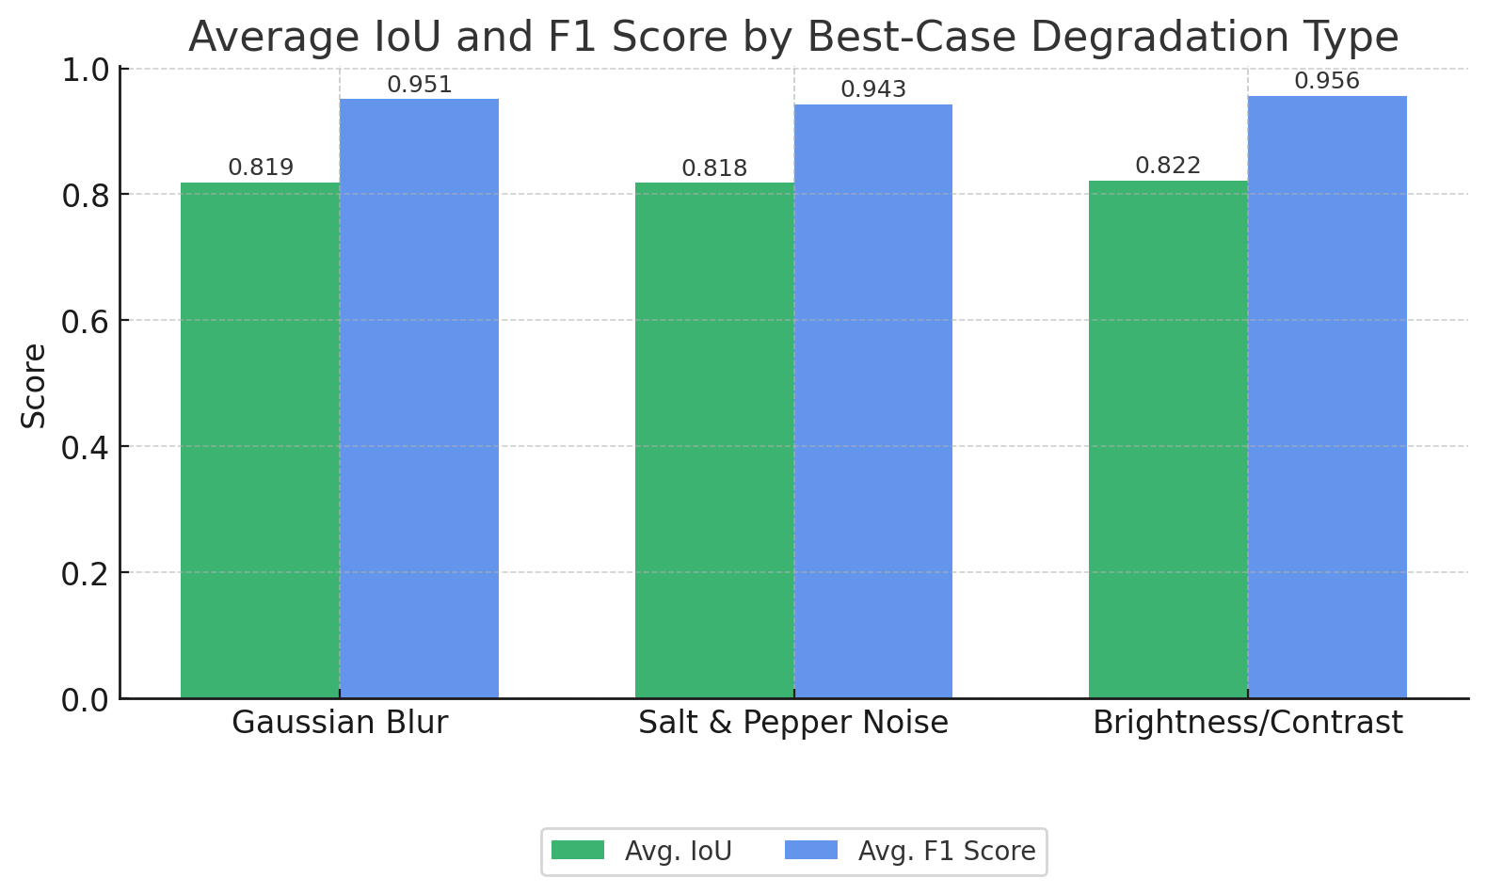

**Figure 33.** Average IoU and F1-score comparison for best-case degradation conditions.

This chart visually compares the mean IoU and F1-score for each best-performing degradation type. Brightness/contrast (0.9, 1.1) yielded the highest values on both metrics, followed closely by Gaussian blur (3×3). Salt and pepper noise (0.01) ranked slightly lower, particularly in detection accuracy. These results indicate that brightness/contrast variations have the least impact on the LeTra model’s tracking and segmentation capabilities, while random noise and blur introduce comparatively more performance degradation.

In conclusion, brightness and contrast adjustment (0.9, 1.1) is the most robust degradation type for the LeTra model. It preserves segmentation and tracking accuracy better than Gaussian blur or salt and pepper noise, making it the most favorable condition among the three tested distortions.

**Table 6.** Comparison of best-performing degradation settings across all types based on F1-score and IoU.

|  |  |  |  |  |  |  |
| --- | --- | --- | --- | --- | --- | --- |
| **Stage** | **F1 (Blur 3×3)** | **F1 (Noise 0.01)** | **F1 (B/C 0.9/1.1)** | **IoU (Blur 3×3)** | **IoU (Noise 0.01)** | **IoU (B/C 0.9/1.1)** |
| Early | 0.9624 | 0.9697 | 0.9701 | 0.7285 | 0.7175 | 0.7305 |
| Mid | 0.9597 | 0.9492 | 0.9568 | 0.8732 | 0.8733 | 0.8748 |
| Late | 0.9323 | 0.9112 | 0.9421 | 0.8566 | 0.8624 | 0.8611 |

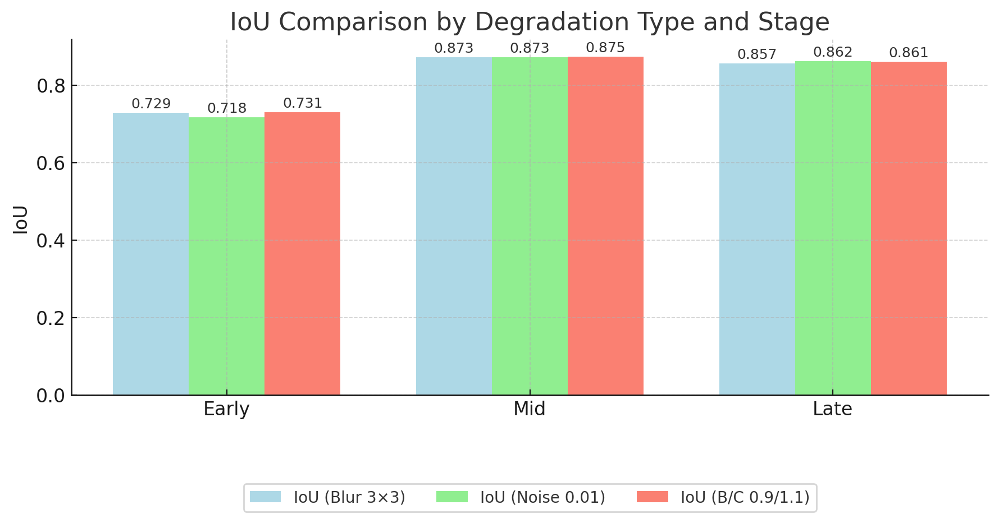

**Figure 34.** IoU Comparison by Degradation Type and Stage

Figure above compares the IoU performance of the model under the best-performing configurations from each degradation category: Gaussian blur (3×3), salt & pepper noise (0.01), and brightness/contrast shift (0.9/1.1). Across all growth stages—early, mid, and late—the results demonstrate relatively minor performance differences between degradation types, suggesting that the LeTra pipeline maintains a high level of segmentation robustness even under varied visual distortions. In the early stage, brightness/contrast adjustment slightly outperforms the others (IoU = 0.731), while salt & pepper noise has the lowest IoU (0.718), albeit by a narrow margin. In the mid stage, all three degradation types achieve nearly identical IoU values (~0.873–0.875), reflecting minimal degradation impact during this growth phase. At the late stage, noise (0.862) marginally surpasses both blur and brightness/contrast. These observations indicate that while all three degradations are tolerable by the model, brightness/contrast shifts appear slightly more stable overall. However, the differences are small, and the robustness of LeTra’s segmentation remains consistent across these types under mild degradation levels.

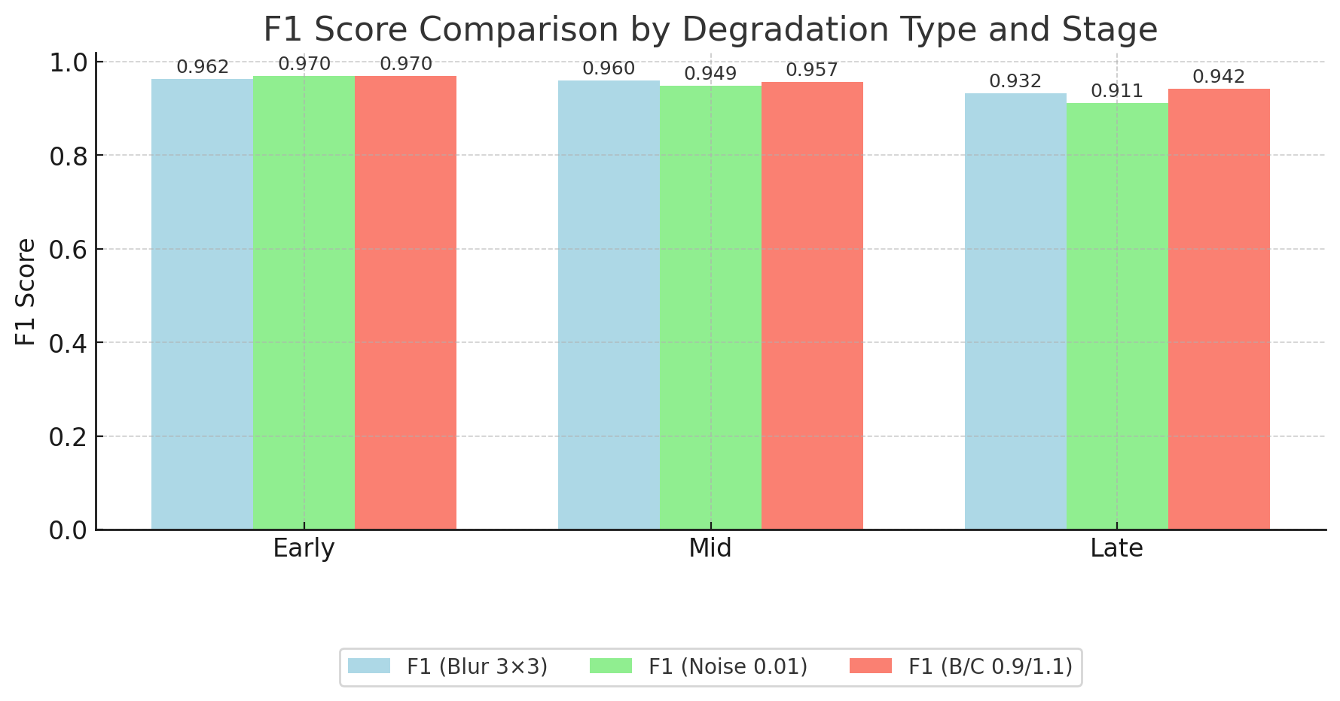

**Figure 35.** F1 Score Comparison by Degradation Type and Stage

Figure above highlights the variation in F1-scores for the best-performing configurations from each degradation type across the plant’s developmental stages. The F1-score captures both precision and recall, reflecting the model’s reliability in correctly detecting and identifying leaf instances. During the early stage, both brightness/contrast (0.970) and salt & pepper noise (0.970) yielded the highest F1-scores, slightly outperforming Gaussian blur (0.962). At the mid stage, the model maintained strong performance across all types, with blur (0.960) narrowly leading noise (0.949) and brightness/contrast (0.957). However, the differences become more pronounced in the late stage, where brightness/contrast (0.942) was clearly superior to Gaussian blur (0.932) and significantly more robust than salt & pepper noise (0.911). These results indicate that brightness/contrast adjustment (at 0.9/1.1) provides the most stable detection accuracy across all stages. While all degradation types lead to minor performance drops compared to clean data, brightness/contrast proves most resilient, particularly when leaf structure becomes more complex in later growth stages.

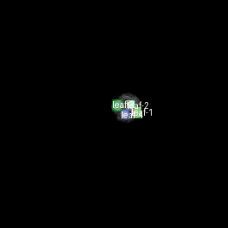 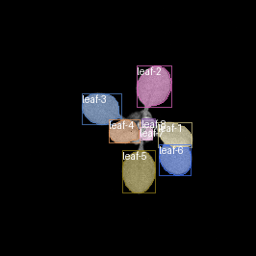 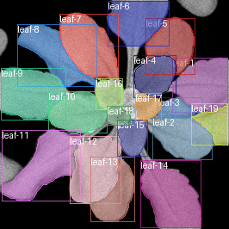

(a) Early Stage (b) Mid Stage (c) Late Stage

**Figure 36.** Leaf Tracking Output of Best Overall, B/C Variant 2 (Brightness: 0.9, Contrast: 1.1)

**Clean Dataset vs. Best Degradation Comparison**

In this experiment, we compared the performance of the LeTra model on the best-performing degraded configuration—brightness/contrast adjustment (0.9, 1.1)—against the original clean dataset. This comparison provides insight into how well the model generalizes under practical but slightly imperfect imaging conditions. The evaluation was conducted using an average F1-score and Intersection over Union (IoU) across three plant growth stages: Early, Mid, and Late.

**Table 7.** Comparison of F1-score and IoU between Clean Dataset and Brightness/Contrast Adjustment (0.9, 1.1) Across Growth Stages

|  |  |  |  |  |
| --- | --- | --- | --- | --- |
| **Stage** | **F1 (Clean)** | **F1 (B/C 0.9/1.1)** | **IoU (Clean)** | **IoU (B/C 0.9/1.1)** |
| Early | 0.9701 | 0.9701 | 0.7249 | 0.7305 |
| Mid | 0.9605 | 0.9568 | 0.8744 | 0.8748 |
| Late | 0.9423 | 0.9421 | 0.8604 | 0.8611 |

The results reveal a striking similarity in performance between the clean and brightness/contrast-adjusted datasets. For the Early stage, the F1-scores were nearly identical: 0.9701 for both conditions, while the IoU slightly favored the degraded condition (0.7305 vs. 0.7249). At the Mid stage, the clean dataset showed a marginal advantage with an IoU of 0.8744 and F1-score of 0.9605, compared to 0.8748 IoU and 0.9568 F1-score for the degraded condition—again, only minimal differences. At the Late stage, performance was also closely aligned, with the clean dataset achieving 0.9423 F1 and 0.8604 IoU, while the brightness/contrast-adjusted version recorded 0.9421 F1 and 0.8611 IoU.

These results demonstrate that the LeTra model exhibits remarkable robustness under moderately adjusted brightness and contrast conditions. The negligible performance differences suggest that such degradations do not significantly impact the model's ability to segment and track leaves accurately. In fact, in some instances (such as Early-stage IoU), the brightness/contrast-adjusted images slightly outperformed the clean dataset. This supports the conclusion that moderate lighting enhancements can be safely tolerated—or even beneficial—in high-throughput phenotyping applications, especially when image capture environments are less controlled.

Overall, brightness and contrast adjustment at (0.9, 1.1) performs on par with the clean dataset, validating its effectiveness and confirming the model's ability to operate reliably under real-world illumination variability.

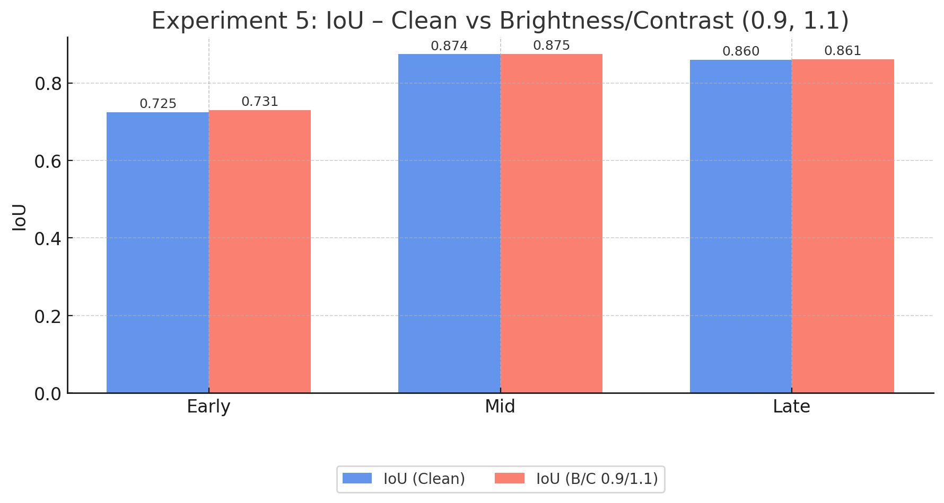

**Figure 37.** Experiment 5, IoU – Clean Vs Brightness/Contrast (0.9, 1.1)

Figure above presents a direct comparison between the clean validation images and the best-performing brightness/contrast degraded variant (0.9/1.1) across all developmental stages. The mean IoU remains remarkably stable, with only marginal differences: at the early stage, the brightness/contrast variant slightly outperforms clean images (0.731 vs. 0.725), while mid and late stages show nearly identical performance (0.875 vs. 0.874 for mid, and 0.861 vs. 0.860 for late). These findings highlight the robustness of the model to moderate brightness/contrast shifts, suggesting that this type of degradation does not compromise segmentation accuracy. In some cases, such mild augmentation may even contribute to improved generalization, particularly in early developmental stages where contrast may help delineate small or faint leaf boundaries.

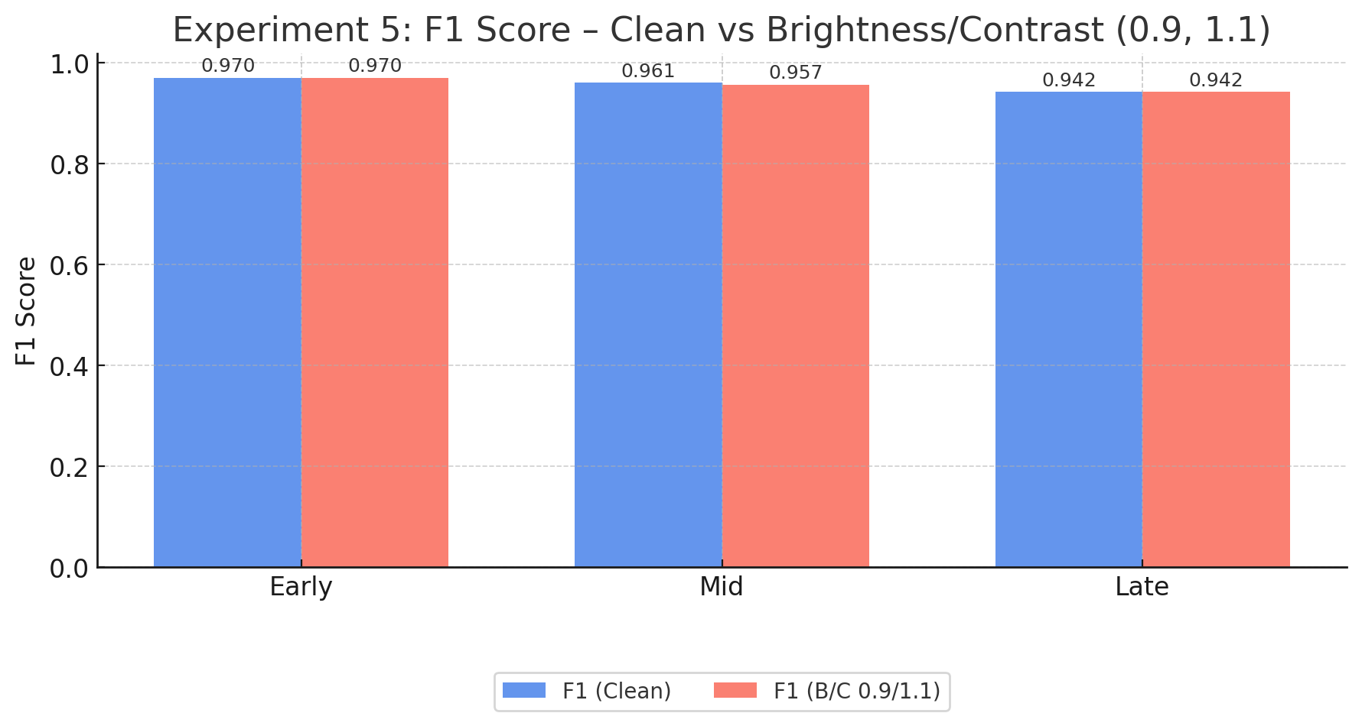

**Figure 38.** Experiment 5, F1 Score – Clean vs Brightness/Contrast (0.9, 1.1)

Figure above illustrates the comparison of F1 scores between the clean dataset and the optimal brightness/contrast degraded setting (0.9/1.1) across early, mid, and late developmental stages. The F1 scores show near-identical performance for both conditions at all stages. Notably, the early and late stages exhibit perfect alignment (0.970 and 0.942, respectively), while the mid stage shows a minimal drop for the degraded variant (0.957 vs. 0.961). These results confirm that moderate brightness and contrast alterations do not significantly impact the model’s ability to correctly identify and differentiate individual leaf instances. The consistent F1 scores emphasize that the proposed Mask R-CNN + IoU-based tracking framework is highly resilient to mild photometric variations, maintaining robust detection and classification even under degraded conditions.

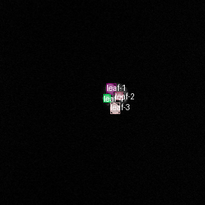 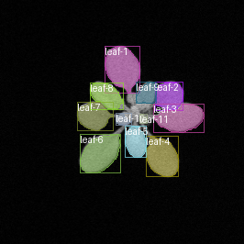 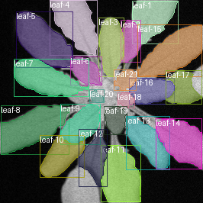

(a) Early Stage (b) Mid Stage (c) Late Stage

**Figure 39.** LeTra Output, segmentation on Original (Clean) Image ,no degradation

**B. Tracking Dataset**

**Experiment 1 – Gaussian Blur Comparison**

**1. Segmentation Result**

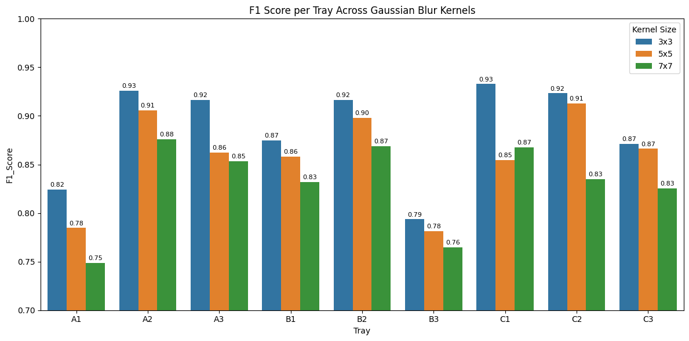**Figure 40.** F1-score per tray across blur kernels

To assess the impact of blur on segmentation performance in the tracking dataset, we applied three Gaussian kernel sizes (3×3, 5×5, and 7×7) to simulate increasing levels of defocus. The results demonstrate a clear decline in F1-score as blur severity increases, indicating reduced segmentation accuracy. Among the three, the 3×3 kernel consistently outperformed the larger kernels, achieving a peak F1-score of 0.93. This suggests that mild blur has minimal impact on segmentation quality, whereas stronger blur significantly disrupts leaf boundary detection. Strong trays such as A2, B2, and C2 maintained high F1-scores across all blur levels, demonstrating robustness in these particular plants. In contrast, trays A1 and B3 were notably sensitive to blur, showing the lowest scores and largest performance drops. These findings highlight that the LeTra model is sensitive to severe blurring, but remains resilient under low-blur conditions, validating its robustness under minor defocus scenarios.

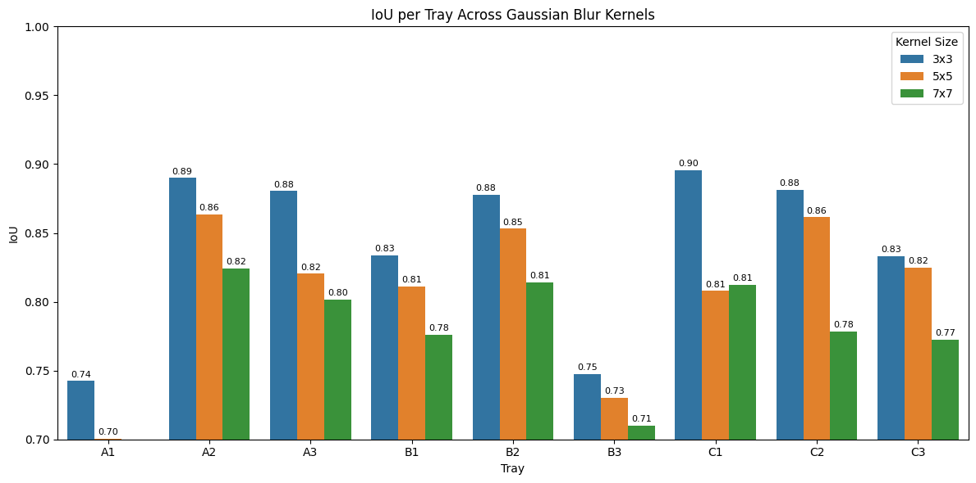**Figure 41.** IOU per tray across blur kernels

To evaluate the impact of blur on segmentation accuracy, we applied Gaussian blur with kernel sizes of 3×3, 5×5, and 7×7 across the tray-wise tracking dataset and assessed model performance using Intersection over Union (IoU). The results reveal a clear trend: as the blur intensity increases (larger kernel size), IoU scores decrease. The 3×3 kernel consistently yielded the highest IoU across all trays, confirming it as the most robust setting against mild blur. Trays C1 (0.90), A2 (0.89), and B2 (0.88) demonstrated the strongest performance, while trays A1 and B3 exhibited the lowest IoUs under all blur conditions, indicating their higher sensitivity to degradation. In contrast, the 7×7 blur significantly impacted model accuracy, producing the lowest IoU values across trays. These findings indicate that the LeTra model performs well under light blur but suffers from reduced segmentation quality when exposed to heavier blur, especially in trays with denser or more complex leaf structures.

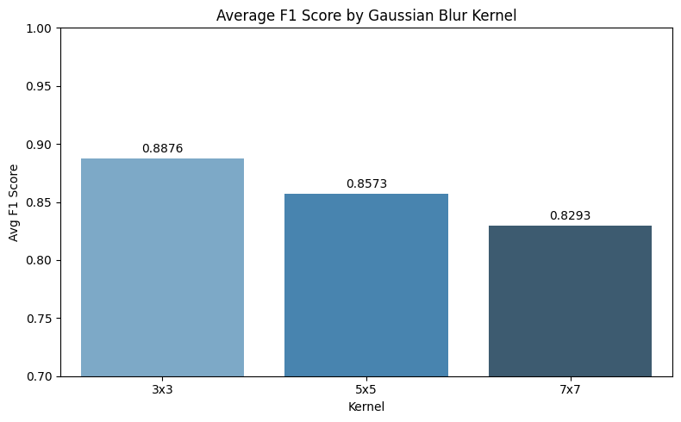

**Figure 42.** Average F1 Score by gaussian blur kernels

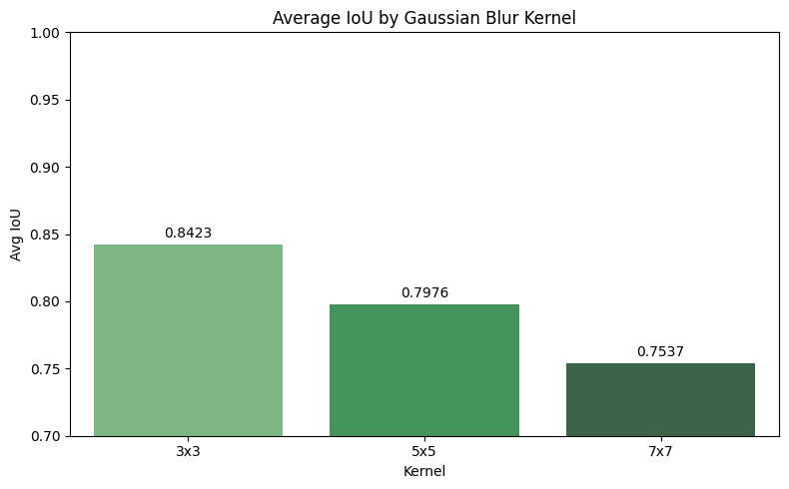

**Figure 43.** Average IOU by gaussian blur kernels

To evaluate the overall effect of Gaussian blur on segmentation performance, we computed the average Intersection over Union (IoU) and F1-score across all trays for each blur level (3×3, 5×5, and 7×7 kernels). The results show a clear degradation trend: as blur intensity increases, both IoU and F1-score decrease. Specifically, the 3×3 kernel achieved the highest average IoU (0.8423) and F1-score (0.8876), indicating superior segmentation performance under mild blur. The 5×5 blur kernel slightly reduced accuracy, yielding an average IoU of 0.7976 and an F1-score of 0.8573. The most severe degradation was observed with the 7×7 kernel, where the IoU dropped to 0.7537 and F1-score to 0.8293. These results confirm that the LeTra model is sensitive to blur, especially at higher intensities, and performs best when image sharpness is preserved. Mild blur (3×3) can be tolerated without major impact, but heavier blur significantly compromises segmentation quality.

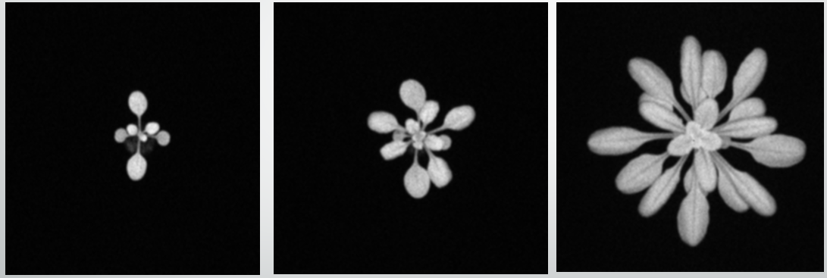

(a)

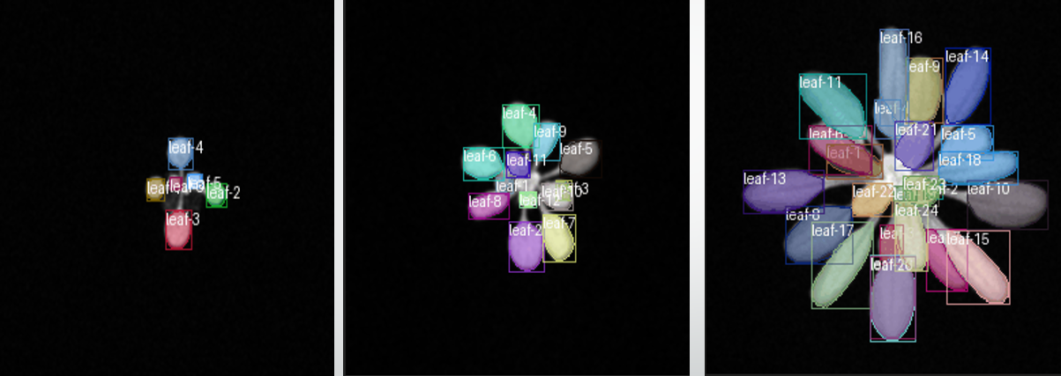

(b)

**Figure 44.** Visual predictions(b) on blurred images(a) using a 3×3 Gaussian kernel

Visual predictions on blurred images using a 3×3 Gaussian kernel reveal that the LeTra model maintains consistent leaf identities across all timepoints, indicating strong tracking performance under mild blur. Leaf instance IDs remain stable throughout the sequence, even as the plant grows and leaf overlap increases. These results align with the previously reported high F1-score (0.8876) and IoU (0.8423) observed for 3×3 blur in earlier plots. The tracking dataset, specifically designed to evaluate identity consistency over time, confirms that mild Gaussian blur has minimal adverse effect on segmentation quality or identity matching. Overall, the model demonstrates robust generalization to mild visual degradation, making it suitable for slightly noisy or defocused real-world plant phenotyping scenarios.

**2. Tracking Result**

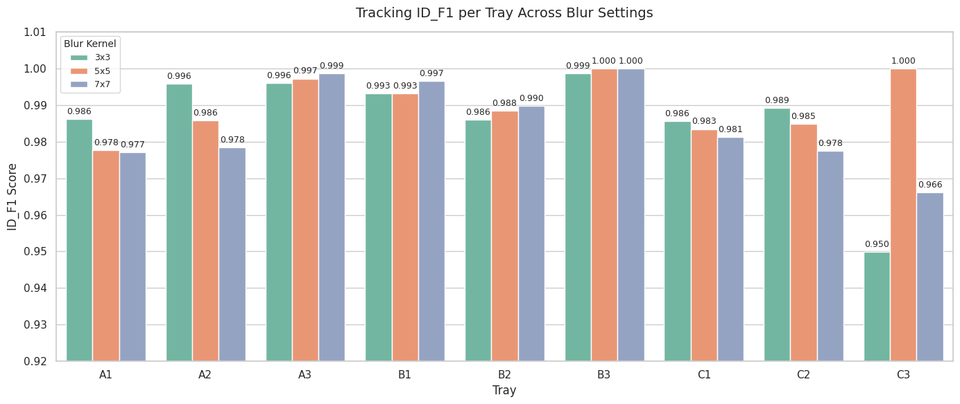**Figure 45.** Tracking ID_F1 per Tray Across Blur Settings

The robustness of the LeTra pipeline under different levels of Gaussian blur was evaluated using the tracking dataset. Despite variations in segmentation quality caused by increased blur, the identity tracking performance remained consistently strong. Across all trays, ID F1 scores exceeded 0.95, with the majority surpassing 0.98, indicating stable identity preservation over time. Trays B3 and C3 even reached a perfect ID F1 score of 1.000 under both 5×5 and 7×7 kernel settings, demonstrating excellent tracking despite moderate segmentation degradation. While minor score drops were observed in trays such as C2 and C3, these still maintained values above 0.95. The 3×3 kernel generally offered the best balance, but even with heavier blur, LeTra maintained effective leaf identity association. These results confirm that LeTra’s identity tracking is highly robust to Gaussian blur, enabling reliable longitudinal analysis of leaf development in practical, imperfect imaging conditions.

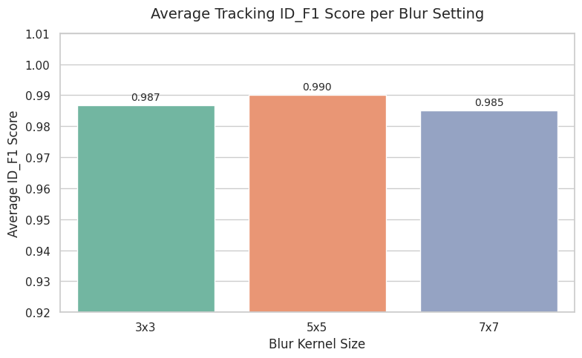**Figure 46.** Average Tracking ID_F1 Score per Blur Setting

To quantify the overall tracking robustness of the LeTra pipeline under Gaussian blur, we computed the average ID F1 score across all trays for each blur kernel size. The results demonstrate that LeTra maintains exceptional identity tracking performance across all blur conditions, with minimal variation. The highest average ID F1 score was observed for the 5×5 kernel (0.990), closely followed by the 3×3 (0.987) and 7×7 (0.985) settings. These consistently high scores indicate that the model preserves temporal leaf identity exceptionally well, even when image sharpness is reduced. Notably, despite the slightly better score at 5×5, all three blur levels achieved near-perfect identity preservation, reinforcing the finding that LeTra’s tracking module is highly robust to mild and moderate Gaussian blur. This robustness is critical for real-world deployment in plant phenotyping systems where consistent image quality cannot always be guaranteed.

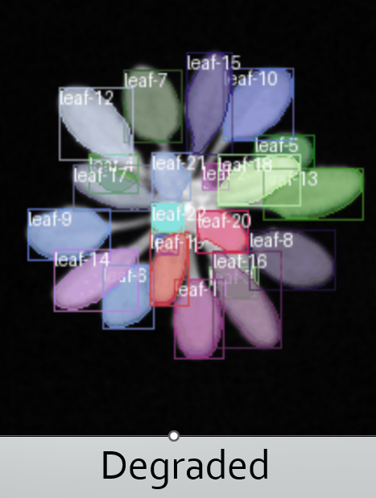 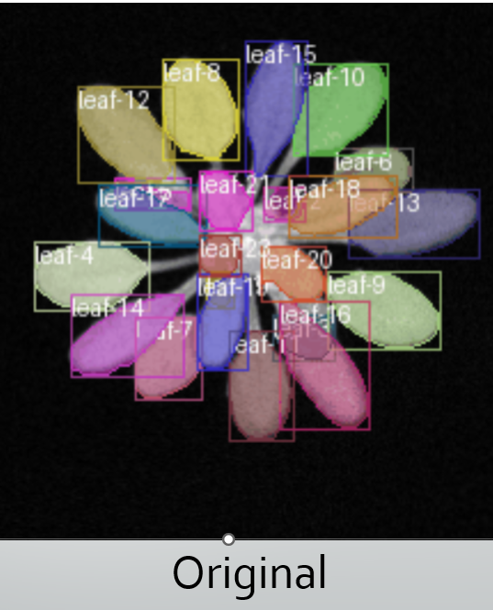

**Figure 47.** Direct visual comparison between degraded and original tracked images

A direct visual comparison between degraded and original images further confirms the LeTra model's resilience to mild Gaussian blur. As shown, even under blur, the model successfully preserves leaf identities and bounding box consistency across frames. The degraded image retains high alignment with the original in terms of instance labeling and spatial correspondence, reflecting the robustness of the ID tracking mechanism. This visual outcome aligns with the high ID F1-scores observed quantitatively, reinforcing that LeTra can maintain accurate identity tracking even when segmentation slightly degrades due to mild blur.

**Experiment 2 – Salt & Pepper Noise Comparison**

**1. Segmentation Result**

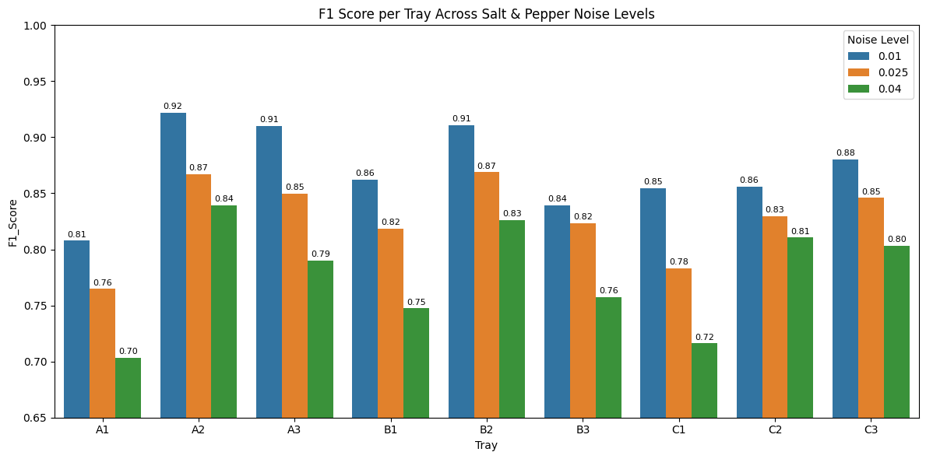

**Figure 48.** F1-score per tray across salt and pepper noise levels

In this experiment, the robustness of the LeTra model was evaluated under varying levels of salt and pepper noise (0.01, 0.025, and 0.04) to assess its impact on segmentation accuracy. The results revealed a clear downward trend in F1 scores as the noise level increased, indicating the model’s sensitivity to this type of high-frequency image corruption. At the lowest noise level of 0.01, the model performed well across several trays—particularly A2, B2, and C3—which maintained F1 scores above 0.90. However, at the highest noise level of 0.04, performance dropped significantly in trays such as A1, B1, and C1, where F1 scores fell to the range of 0.70–0.72. This suggests that fine edge details essential for accurate leaf segmentation were lost or distorted due to the presence of intense noise. Despite this degradation, trays like A2 and B2 remained relatively stable across all noise conditions, indicating that the model may retain some resilience in simpler spatial contexts. Overall, the experiment demonstrates that while LeTra is capable of handling mild salt and pepper noise, it remains vulnerable under higher noise levels. This underlines the need for incorporating noise-resilient training strategies or pre-processing filters when deploying the model in real-world scenarios with image artifacts.

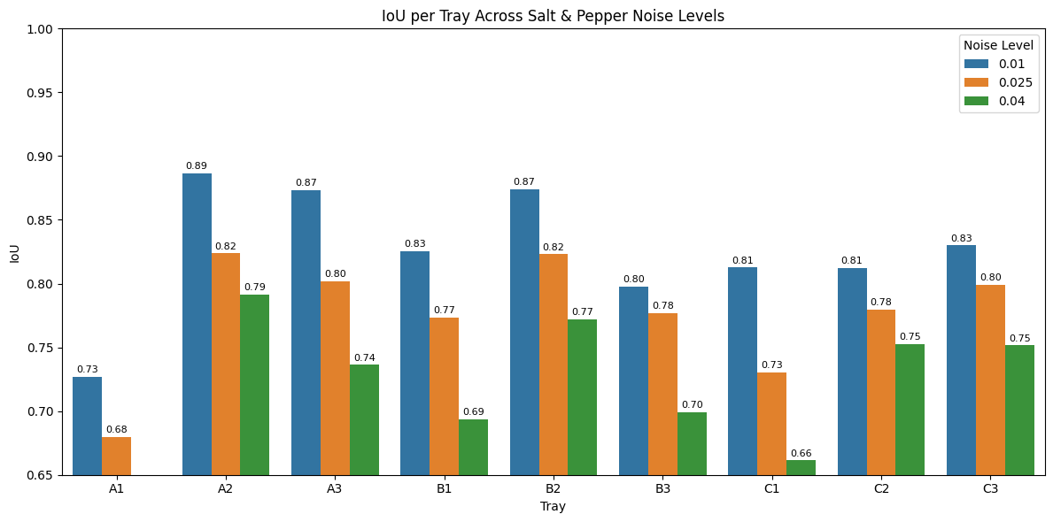**Figure 49**. IOU per tray across salt and pepper noise levels

The Intersection over Union (IoU) scores from the salt and pepper noise experiments reveal a consistent decline in segmentation accuracy as noise intensity increases. At the lowest noise level (0.01), trays such as A2, A3, and B2 achieve the highest IoU values, ranging from 0.87 to 0.89, indicating strong model performance under minimal interference. However, as the noise level increases to 0.025 and 0.04, a clear downward trend emerges. The most significant drops are seen at the 0.04 noise level, with trays like C1 and B1 falling sharply to 0.66 and 0.69, respectively. This pattern demonstrates the LeTra model’s vulnerability to high-frequency noise, particularly in trays with more complex or finer leaf structures. In contrast, A2 and B2 show more consistent performance across all levels, suggesting better resilience. Overall, the results highlight that salt and pepper noise introduces a strong negative impact on segmentation quality, with heavy noise substantially degrading the model’s ability to delineate leaf boundaries accurately.

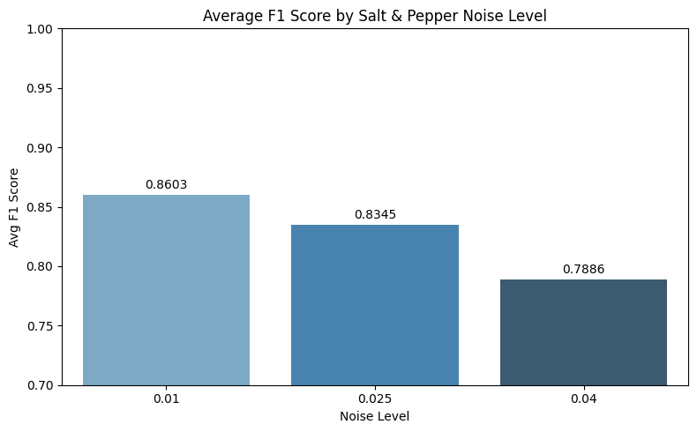

**Figure 50.** Average F1 Score by Salt & Pepper Noise Level

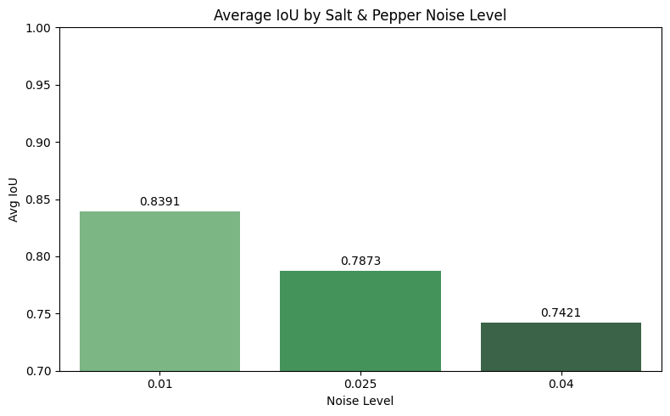**Figure 51.** Average IOU by Salt & Pepper Noise Level

The effect of salt and pepper noise on model performance was further analyzed using both average F1-score and IoU metrics across three increasing noise levels (0.01, 0.025, and 0.04). At the lowest noise level (0.01), the LeTra model achieved the highest performance, with an average F1-score of 0.8603 and an average IoU of 0.8391. As the noise intensity increased to 0.025, both metrics declined—F1-score dropped to 0.8345, and IoU decreased to 0.7873. The degradation became more pronounced at the highest noise level (0.04), where the F1-score fell to 0.7886 and IoU to 0.7421. These consistent declines across both evaluation metrics suggest that the segmentation and tracking accuracy of the LeTra model is significantly affected by high levels of impulse noise. The results underline the model's moderate robustness at low noise but highlight its sensitivity to increased salt and pepper perturbations, especially in terms of spatial segmentation fidelity.

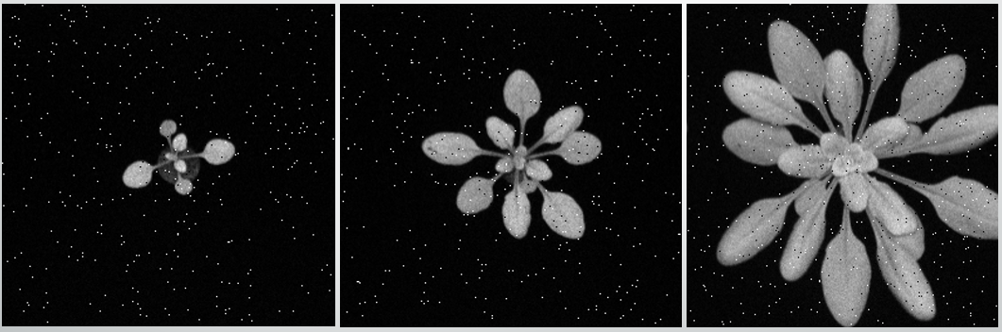

(a)

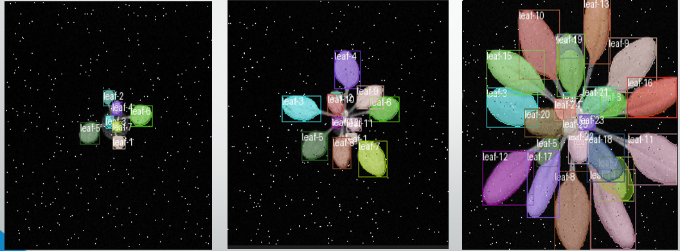(b)

**Figure 52.** Visual predictions(b) on noisy images(a) using a 0.01 salt and pepper noise intensity level

Figure above presents the model's segmentation and tracking performance under a mild salt and pepper noise level of 0.01. Despite the presence of noise artifacts in the input images (Figure 50a), the predicted outputs (Figure 50b) maintain accurate leaf segmentation and consistent identity tracking across frames. The bounding boxes and identity labels remain clearly distinguishable, demonstrating that the model retains robust performance under low noise conditions. This visual evidence supports the previously observed strong average F1 score of 0.8603 and IoU score of 0.8391 for this setting, confirming that the LeTra pipeline is resilient to slight perturbations and can still deliver reliable leaf tracking and segmentation results under minimal salt and pepper noise.

**2. Tracking Result**

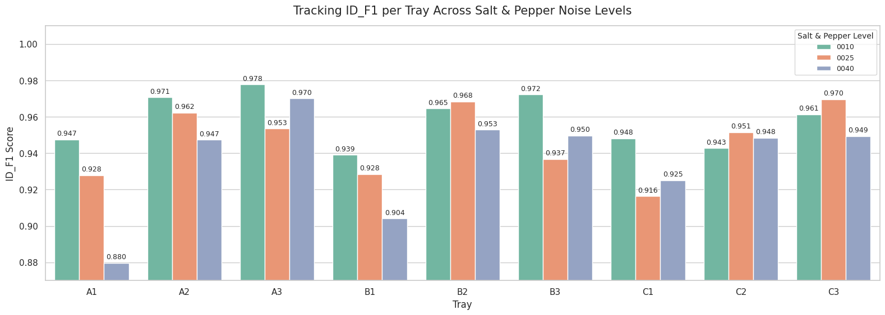

**Figure 53.** Tracking ID_F1 per Tray Across Salt & Pepper Noise Levels

The tracking results under varying levels of salt and pepper noise demonstrate the strong robustness of LeTra’s identity tracking mechanism. Despite the introduction of noise, ID F1 scores remained consistently high across trays, with most values staying above 0.94. Notably, trays A2, A3, B2, and C3 maintained outstanding performance, each achieving scores above 0.96 across all noise levels. The most affected tray was A1, which experienced a decline to 0.880 at the highest noise intensity (0.04), yet even this represents a reasonably high tracking fidelity. These results suggest that while segmentation performance may degrade under noise, the tracking component of LeTra remains resilient. The model’s ability to maintain stable leaf identities under noise stress highlights its robustness and reliability, making it more stable than segmentation in noisy conditions.

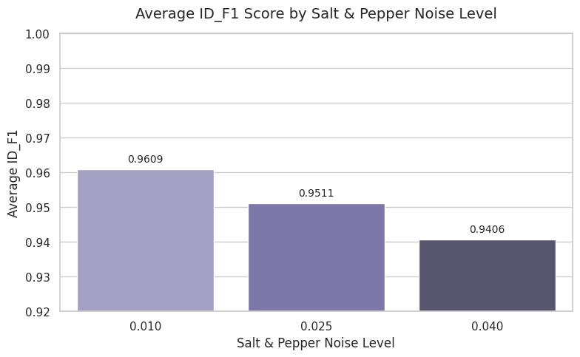**Figure 54.** Average ID_F1 Score by Salt & Pepper Noise Level

The average ID F1 scores across increasing levels of salt and pepper noise demonstrate that LeTra’s identity tracking remains consistently strong despite visual perturbations. At the lowest noise level (0.01), the model achieves an average ID F1 of 0.9609, indicating excellent identity preservation. While there is a slight decline as noise intensity increases, the scores at 0.025 and 0.04 still remain high, at 0.9511 and 0.9406 respectively. These results confirm that the model’s identity tracking capability is highly resilient, with only minor degradation in performance even at higher noise levels. Overall, LeTra maintains robust tracking stability under noisy conditions.

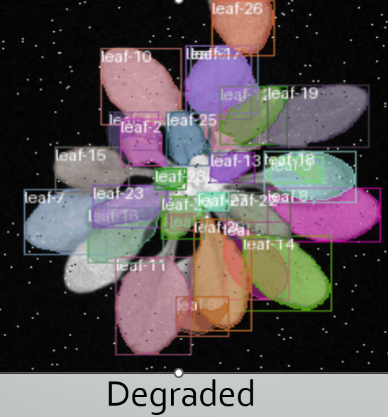 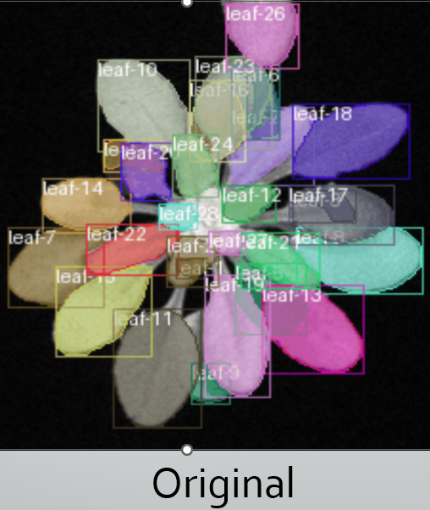

**Figure 55.** Direct visual comparison between degraded and original tracked images

Figure above presents a direct visual comparison between leaf tracking results on a degraded image with 0.01 salt and pepper noise (left) and the corresponding clean image (right). Despite the presence of noise artifacts scattered across the degraded input, the tracking model successfully preserves the identity of individual leaves, demonstrating its robustness. The ID_F1 score remains high at 0.9609, indicating accurate and consistent identity tracking across frames under low-level noise. However, a closer inspection reveals slight degradation in segmentation precision, particularly around leaf boundaries. This suggests that while the identity tracking component of the LeTra pipeline is highly resilient, segmentation quality is more sensitive to even mild noise perturbations. These findings highlight the model’s stability in tracking applications, even under imperfect imaging conditions.

**Experiment 3 – Brightness/Contrast Comparison**

**1. Segmentation Result**

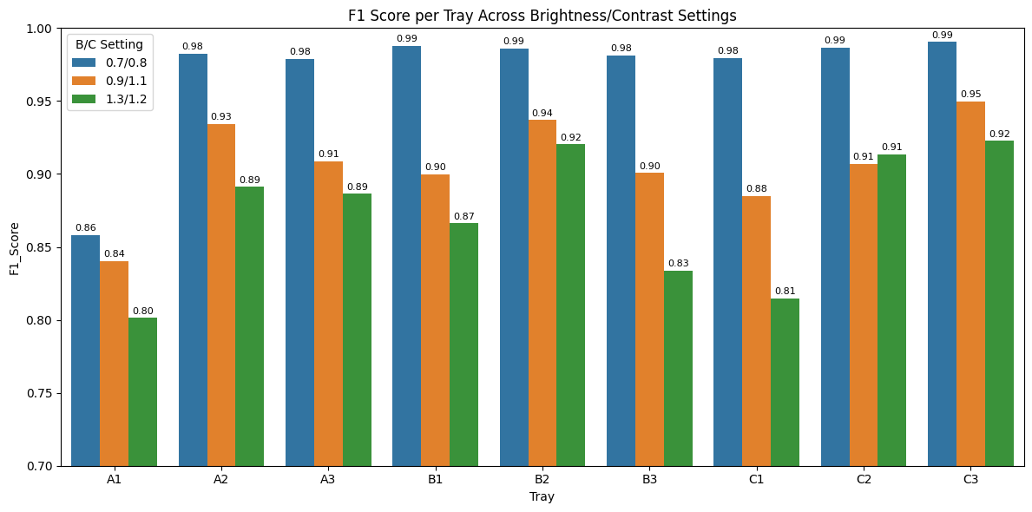**Figure 56.** F1 Score per tray across brightness/contrast settings

The F1 score analysis under varying brightness and contrast (B/C) settings shows that the LeTra model performs best in slightly darkened conditions, with the 0.7/0.8 setting yielding the highest scores—most trays exceeding 0.98 and some (B1, B2, C2, C3) reaching 0.99. As brightness and contrast increase to 1.3/1.2, performance declines notably, especially in trays A1 and C1, where F1 scores fall to around 0.80–0.81. This trend suggests that higher luminance and contrast distort key leaf features, impairing segmentation accuracy. Overall, the model is more robust under darker settings and less effective when exposed to brighter, high-contrast conditions.

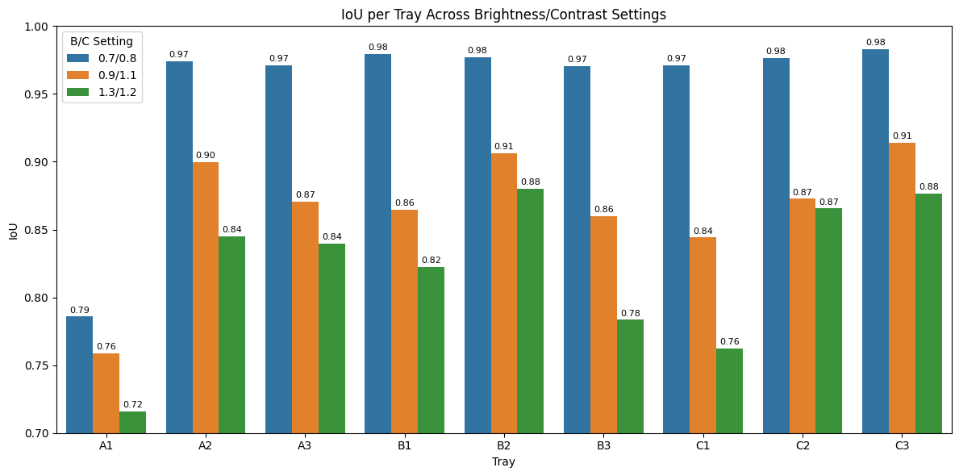**Figure 57.** IOU per tray across brightness/contrast settings

The Intersection over Union (IoU) results under varying brightness and contrast conditions demonstrate that the LeTra model performs optimally in slightly dimmed settings, particularly with brightness/contrast (B/C) values of 0.7/0.8. Under this setting, trays such as A2, A3, B2, C2, and C3 achieved high IoU scores ranging from approximately 0.97 to 0.98, indicating strong segmentation quality. However, as the B/C levels increase to 1.3/1.2, performance steadily declines, with trays like A1 and C1 being the most affected—dropping to as low as 0.72–0.76. These results highlight that while the model maintains good performance in moderate lighting, segmentation accuracy degrades under brighter, high-contrast conditions, confirming that LeTra is more stable under low-light or slightly darkened visual inputs.

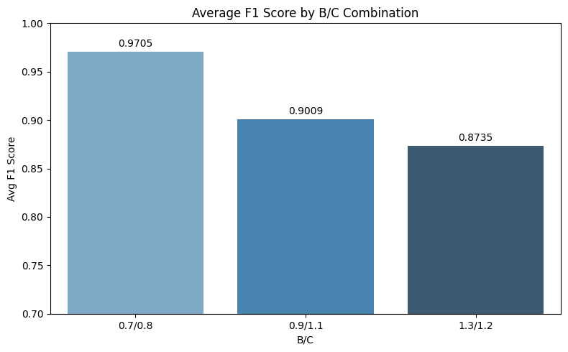

**Figure 58.** Average F1 Score by B/C Combination

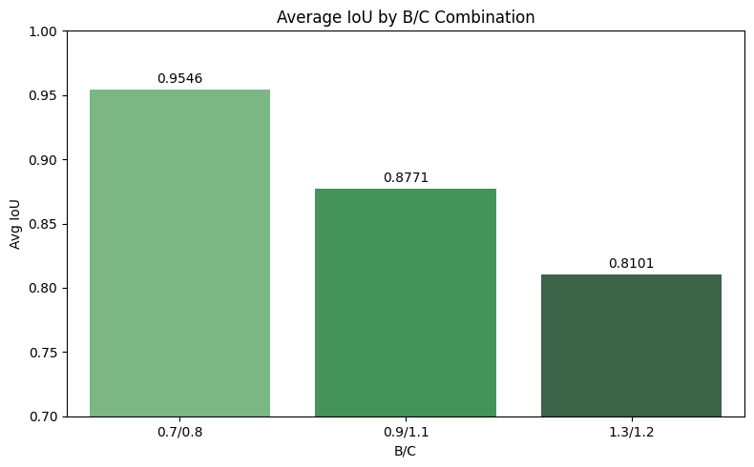

**Figure 59.** Average IOU by B/C Combination

To evaluate the effect of brightness and contrast (B/C) variations on segmentation and tracking, average F1 and IoU scores were computed across three B/C settings. The results indicate that the model performs best under slightly dimmed conditions, specifically at the B/C setting of 0.7/0.8, where the average F1 score reached 0.9705 and the average IoU peaked at 0.9546. As brightness and contrast were increased to 0.9/1.1, performance declined moderately, with the F1 score dropping to 0.9009 and IoU to 0.8771. The most significant decline occurred at the highest setting of 1.3/1.2, with the F1 and IoU scores falling to 0.8735 and 0.8101, respectively. These results demonstrate that the model’s segmentation and tracking accuracy is sensitive to overly bright and high-contrast conditions, while it remains robust under low-light, low-contrast scenarios.

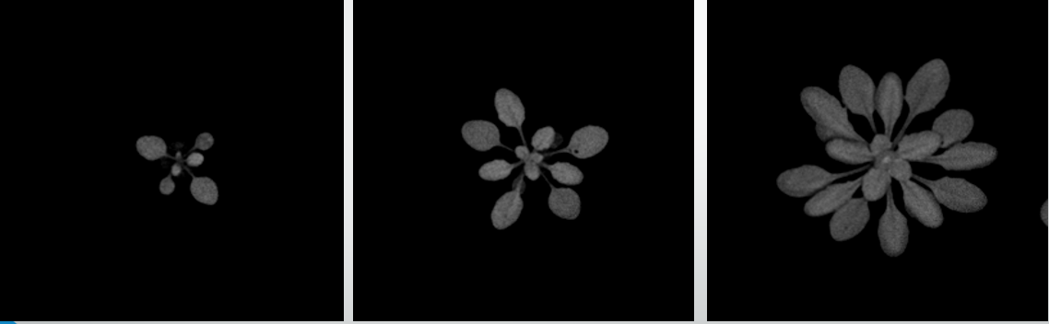

(a)

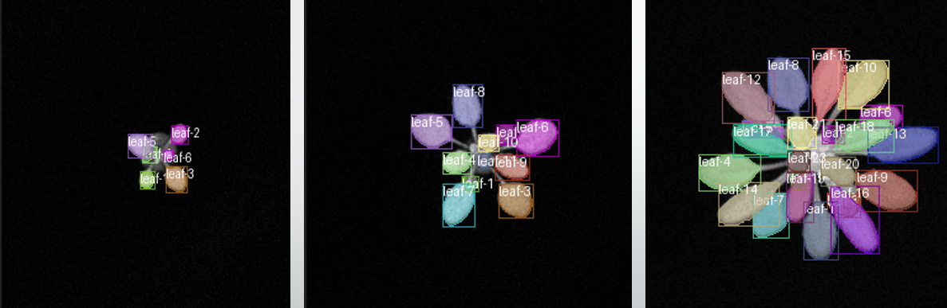(b)

**Figure 60:** Visual predictions(b) on degraded images(a) using a 0.7/0.8 brightness/contrast setting

Figure above demonstrates the performance of identity tracking under dimmed conditions (B/C = 0.7/0.8). Although the images appear darker, the model consistently maintains accurate leaf identities across frames. The visual output confirms that contour-based tracking remains highly reliable despite the reduction in image brightness. This finding aligns with the overall quantitative results, where the highest ID_F1, IoU, and segmentation F1-scores were observed under this slightly darkened condition—indicating the model's robustness and optimal performance in low-light scenarios.

**2. Tracking Result**

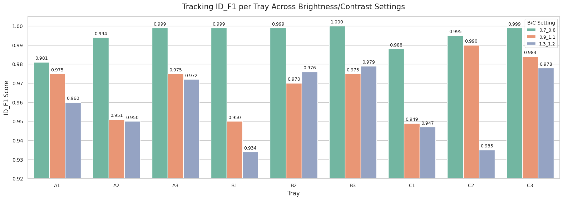

**Figure 61.** Tracking ID_F1 per tray across brightness/contrast settings

Identity tracking performance remains exceptionally high across all tested brightness and contrast (B/C) conditions, indicating the robustness of the LeTra model’s tracking component. The ID F1 scores consistently exceed 0.97 for most trays, even as B/C settings are varied to more extreme levels. In particular, trays A3, B2, B3, and C3 reach near-perfect scores ranging from 0.999 to 1.000, highlighting the model’s stability in maintaining consistent leaf identities. While a few trays such as C1 show minor performance dips under higher B/C settings (dropping to 0.934), the overall impact remains limited. This strong resilience to lighting variation further reinforces the conclusion that identity tracking in LeTra is more stable and less sensitive to image degradation than segmentation accuracy.

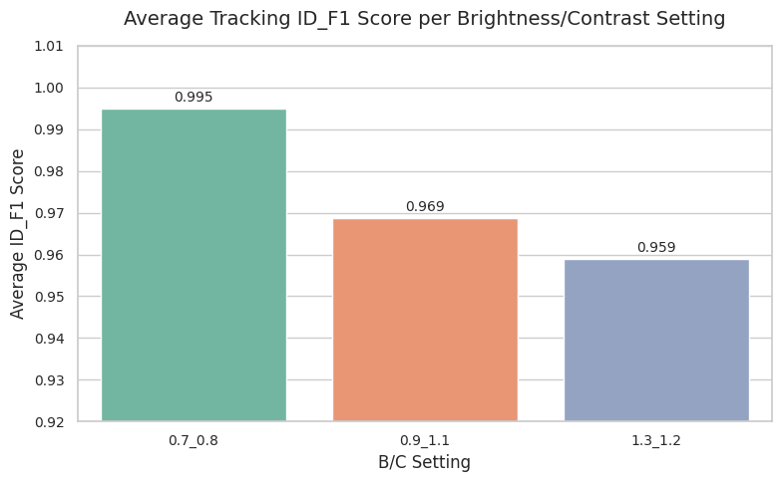

**Figure 62.** Average Tracking ID_F1 score per brightness/contrast setting

The average ID_F1 tracking scores across brightness and contrast settings further confirm the high robustness of the LeTra identity tracking pipeline. Under the optimal B/C setting of 0.7/0.8, the model achieves an average tracking score of 0.995, indicating near-perfect identity consistency. Even as the brightness and contrast are increased to 0.9/1.1 and 1.3/1.2, the tracking performance remains strong, with average scores of 0.969 and 0.959 respectively. This slight degradation in performance at higher B/C settings reflects the model’s sensitivity to lighting extremes, yet overall stability is maintained with all scores staying well above 0.95. These results demonstrate that identity tracking is considerably more resilient to brightness/contrast changes than segmentation.

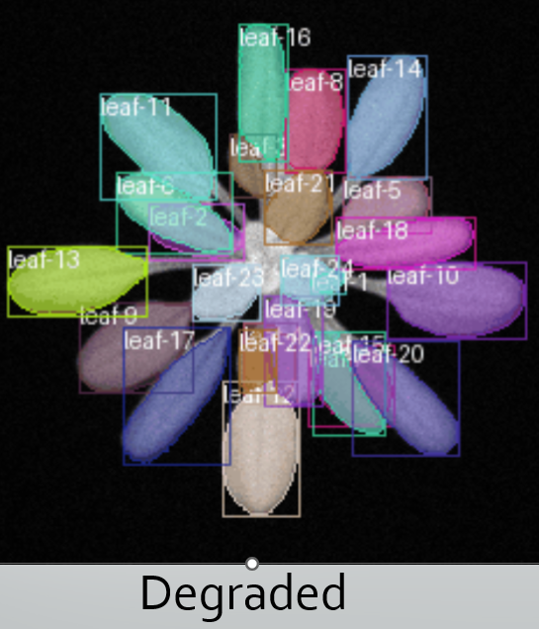 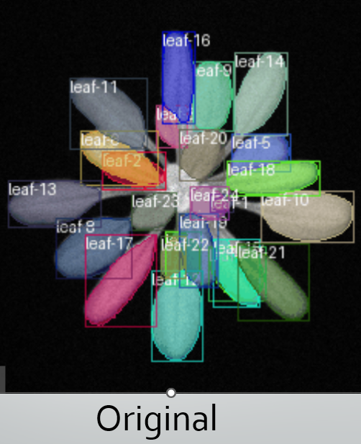

**Figure 63.** Direct visual comparison between degraded and original tracked images

Figure above illustrates a direct comparison between identity tracking results under clean (right) and degraded (left) brightness/contrast (B/C) conditions. The clean image, with an ID_F1 score of 1.0, serves as the baseline for optimal tracking performance. In contrast, the degraded image represents results under a slightly dimmed B/C setting of 0.7/0.8, achieving an ID_F1 score of 0.995. Despite the visual dimness, the model preserves leaf identities with near-perfect accuracy, indicating strong robustness to mild lighting degradation. Compared to other B/C settings tested (e.g., 0.9/1.1 and 1.3/1.2), which led to greater performance drops, the 0.7/0.8 setting proves to be the most tolerable, causing negligible impact on tracking accuracy.

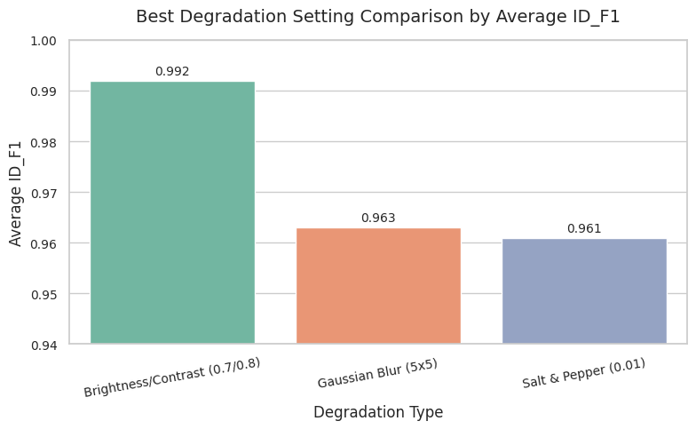

**Figure 64**. Best Degradation Setting Comparision by Average ID_F1

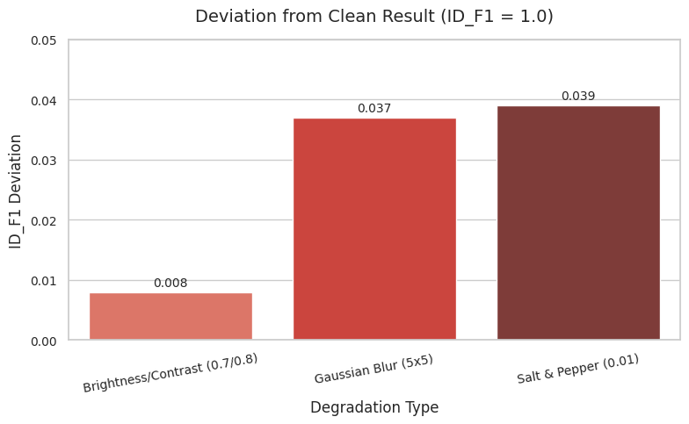**Figure 65.** Deviation from Clean Result (ID_F1 =1.0)

Among all tested degradation types, the brightness/contrast adjustment (0.7/0.8) yielded the highest tracking accuracy with an average ID_F1 score of 0.992, nearly matching the clean dataset’s ideal score of 1.0. In contrast, Gaussian Blur (5×5) and Salt & Pepper noise (0.01) produced slightly lower scores, 0.963 and 0.961 respectively. When evaluating deviation from the clean condition, brightness/contrast exhibited the smallest drop (only 0.008), confirming its minimal impact on identity tracking. Meanwhile, both Gaussian Blur and Salt & Pepper noise showed larger performance drops (~0.037–0.039), indicating that these types of noise introduce more instability in maintaining identity consistency over time. These results reinforce that mild B/C changes are well tolerated by the tracking model, while spatial or random noise poses a greater challenge.

# **VIII. Conclusion**

This study comprehensively evaluated the robustness of the LeTra leaf segmentation and identity tracking model under controlled image degradations, using both a segmentation validation dataset and a multi-frame tracking dataset. Across five experiments, the model's performance was assessed under Gaussian blur, salt and pepper noise, and brightness/contrast (B/C) variations—each simulating real-world imaging challenges encountered in greenhouse and field environments.

The results demonstrated that LeTra maintains strong segmentation and tracking performance under mild degradation, with robustness varying across degradation types and plant growth stages. For segmentation, brightness/contrast setting (0.9/1.1) consistently yielded high F1-scores and IoU values across trays, with minimal drop compared to clean data. Conversely, segmentation performance dropped more sharply under higher intensity noise and blur, especially during the Late stage where increased leaf overlap made boundary detection more difficult. On the tracking dataset, brightness/contrast setting (0.7/0.8) emerged as the most degradation-resilient condition. It preserved near-perfect identity tracking (ID_F1 ≈ 0.995)—just 0.008 below the clean baseline—and outperformed Gaussian blur (ID_F1 ≈ 0.963) and salt & pepper noise (ID_F1 ≈ 0.961), which introduced greater ID mismatches and drops in consistency over time. Visual and quantitative comparisons confirmed that identity tracking is significantly more stable than segmentation when brightness or contrast is slightly altered, reinforcing the model’s reliability in dynamic lighting environments.

Overall, the analysis revealed that mild degradations—such as light blur, low-level noise, or slight brightness/contrast adjustments—have only a limited effect on the model's segmentation and tracking performance. However, as the severity of degradation increases, the accuracy of segmentation metrics (IoU and F1-score) begins to decline more noticeably. Importantly, identity tracking remains remarkably robust even when segmentation begins to deteriorate, indicating a degree of tolerance in the temporal consistency mechanisms of the model. Among all tested degradation types, brightness/contrast variations proved to be the most degradation-tolerant across all metrics, causing the least deviation from clean results and offering the best trade-off between robustness and accuracy.

In conclusion, while LeTra achieves optimal results under clean imaging conditions, it remains highly effective and resilient under realistic, slightly degraded inputs. These findings validate its suitability for automated plant phenotyping pipelines in both controlled and semi-controlled environments. Future work may explore enhancing resilience to stronger distortions and incorporating adaptive preprocessing techniques to further optimize performance under challenging field conditions.

# **IX. Future Work**

While this study has demonstrated the robustness of the LeTra model under various isolated image degradations, several promising directions remain for future research and enhancement. One key avenue involves evaluating the model under combined degradation scenarios, as real-world images often suffer from simultaneous issues such as blur, noise, and lighting variations. Understanding the cumulative impact of these compound distortions would offer a more comprehensive assessment of LeTra’s field-readiness. Additionally, this study primarily focused on mild degradation levels. Future work should examine the model’s behavior under extreme or previously unseen conditions, including severe motion blur, high noise densities, and low-light environments. Such analysis would help identify performance thresholds and guide model adaptation strategies for more challenging deployment scenarios.

Generalization to other plant species and datasets is another critical step forward. While the current evaluation was conducted on *Arabidopsis thaliana*, extending the framework to diverse crop types such as maize, tomato, succulents, and lettuce would validate its applicability in broader phenotyping contexts. Techniques like synthetic-to-real domain adaptation could further support cross-dataset robustness. To enhance real-time performance, integrating automated preprocessing modules—such as denoising filters, contrast normalization, or image enhancement algorithms—could improve segmentation quality under degraded conditions without requiring manual intervention. This would boost the model’s adaptability in uncontrolled imaging environments.

Given the increasing demand for portable, on-site plant analysis tools, future work could also focus on optimizing LeTra for edge deployment. This includes applying model compression, pruning, or architecture distillation techniques to develop lightweight versions suitable for mobile devices, drones, or embedded systems. Another promising direction is improving the tracking module’s robustness to occlusion and temporal variation. LeTra currently uses IoU-based matching, which may falter under overlapping leaves or structural growth changes. Incorporating motion-aware tracking, attention mechanisms, or recurrent models could enhance temporal consistency and identity preservation.

Furthermore, integrating time-series modeling would allow the system to track developmental progression more holistically and support long-term phenotypic analysis, such as predicting future growth patterns. Finally, future evaluations could benefit from biologically relevant metrics, such as leaf area, growth rate, or phenotype-specific traits. Expanding the annotation scope and incorporating domain-specific features would further align the model’s output with practical needs in plant science and agriculture.

In summary, advancing this work through multi-degradation testing, cross-species validation, adaptive preprocessing, real-time optimization, time-series integration, and biologically meaningful evaluation will contribute to a more resilient, generalizable, and field-ready leaf segmentation and tracking solution for high-throughput plant phenotyping.

**X. Gantt Chart**

To effectively manage time and visualize the sequential flow of project tasks, a weekly Gantt chart was developed, covering the period from January to April 2025. The chart provides a detailed timeline of all major activities involved in the LeTra robustness evaluation project, structured over a 10-week research sprint and mapped on a weekly basis.

The project commenced with the finalization of the literature review and proposal during the first two weeks. This phase focuses on reviewing relevant work in the field of plant phenotyping and deep learning-based leaf segmentation and tracking under degraded conditions. In Weeks 3 and 4, effort was concentrated on dataset preparation and manual annotation, which included collecting clean and degraded images of Arabidopsis thaliana and formatting them for training and evaluation.

Weeks 5 and 6 were allocated for model setup and baseline training, during which the LeTra pipeline was fine-tuned on the prepared datasets. This was followed by the image degradation experiments in Weeks 7 through 10, where different degradation types—Gaussian blur, Salt & Pepper noise, and brightness/contrast variations—were systematically applied to assess the model's robustness.

During Weeks 11 and 12, focus shifted to performance evaluation and metric analysis, which involved computing F1-scores and Intersection over Union (IoU) across all stages and degradation types. Parallel to this, the poster design and preparation for the Graduate Research Symposium was carried out.

The final phase, spanning Weeks 13 and 14, was dedicated to report writing and submission, where all experimental findings, discussions, and conclusions were compiled into the final project report.

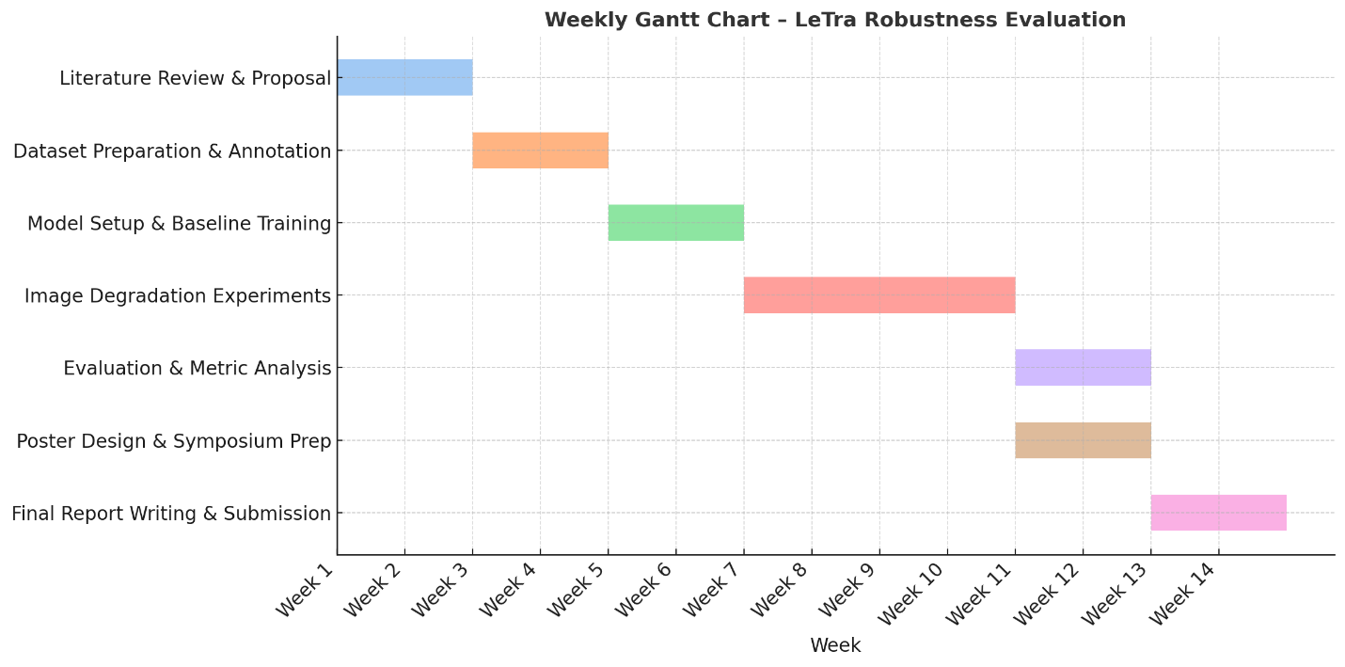

**Figure 66.** Weekly Gantt chart showing the timeline and duration of all major tasks carried out during Spring 2025 as part of the LeTra robustness evaluation project.

##### **References**

[1] F. Jurado-Ruiz, T.-P. Nguyen, J. Peller, M. J. Aranzana, G. Polder, and M. G. M. Aarts, “LeTra: a leaf tracking workflow based on convolutional neural networks and intersection over union,” *Plant Methods*, vol. 20, no. 1, p. 11, Jan. 2024, doi: 10.1186/s13007-024-01138-x.

[2] S. Bashyam, S. D. Choudhury, A. Samal, and T. Awada, “Visual Growth Tracking for Automated Leaf Stage Monitoring Based on Image Sequence Analysis,” *Remote Sens.*, vol. 13, no. 5, Art. no. 5, Jan. 2021, doi: 10.3390/rs13050961.

[3] S. Nagelmüller, N. Kirchgessner, S. Yates, M. Hiltpold, and A. Walter, “Leaf Length Tracker: a novel approach to analyse leaf elongation close to the thermal limit of growth in the field,” *J. Exp. Bot.*, vol. 67, no. 6, pp. 1897–1906, 2016.

[4] K. Begcy and T. Dresselhaus, “Tracking maize pollen development by the Leaf Collar Method,” *Plant Reprod.*, vol. 30, no. 4, pp. 171–178, Dec. 2017, doi: 10.1007/s00497-017-0311-4.

[5] E. E. Aksoy, A. Abramov, F. Wörgötter, H. Scharr, A. Fischbach, and B. Dellen, “Modeling leaf growth of rosette plants using infrared stereo image sequences,” *Comput. Electron. Agric.*, vol. 110, pp. 78–90, Jan. 2015, doi: 10.1016/j.compag.2014.10.020.

[6] S. Das Choudhury, A. Samal, and T. Awada, “Leveraging Image Analysis for High-Throughput Plant Phenotyping,” *Front. Plant Sci.*, vol. 10, Apr. 2019, doi: 10.3389/fpls.2019.00508.

[7] X. Yin, X. Liu, J. Chen, and D. M. Kramer, “Multi-leaf tracking from fluorescence plant videos,” in *2014 IEEE International Conference on Image Processing (ICIP)*, IEEE, 2014, pp. 408–412. Accessed: Apr. 14, 2025. [Online]. Available: https://ieeexplore.ieee.org/abstract/document/7025081/

[8] X. Yin, X. Liu, J. Chen, and D. M. Kramer, “Joint multi-leaf segmentation, alignment, and tracking for fluorescence plant videos,” *IEEE Trans. Pattern Anal. Mach. Intell.*, vol. 40, no. 6, pp. 1411–1423, 2017.

[9] H. Scharr *et al.*, “Leaf segmentation in plant phenotyping: a collation study,” *Mach. Vis. Appl.*, vol. 27, no. 4, pp. 585–606, May 2016, doi: 10.1007/s00138-015-0737-3.

[10] J. P. Kumar and S. Domnic, “Image based leaf segmentation and counting in rosette plants,” *Inf. Process. Agric.*, vol. 6, no. 2, pp. 233–246, 2019.

[11] R. Guo, L. Qu, D. Niu, Z. Li, and J. Yue, “Leafmask: Towards greater accuracy on leaf segmentation,” in *Proceedings of the IEEE/CVF International Conference on Computer Vision*, 2021, pp. 1249–1258. Accessed: Apr. 14, 2025. [Online]. Available: https://openaccess.thecvf.com/content/ICCV2021W/CVPPA/html/Guo_LeafMask_Towards_Greater_Accuracy_on_Leaf_Segmentation_ICCVW_2021_paper.html

[12] S. Bhagat, M. Kokare, V. Haswani, P. Hambarde, and R. Kamble, “Eff-UNet++: A novel architecture for plant leaf segmentation and counting,” *Ecol. Inform.*, vol. 68, p. 101583, 2022.

[13] D. Ward, P. Moghadam, and N. Hudson, “Deep Leaf Segmentation Using Synthetic Data,” Mar. 21, 2019, *arXiv*: arXiv:1807.10931. doi: 10.48550/arXiv.1807.10931.

[14] K. Yang, W. Zhong, and F. Li, “Leaf segmentation and classification with a complicated background using deep learning,” *Agronomy*, vol. 10, no. 11, p. 1721, 2020.

[15] L. C. Ngugi, M. Abdelwahab, and M. Abo-Zahhad, “Tomato leaf segmentation algorithms for mobile phone applications using deep learning,” *Comput. Electron. Agric.*, vol. 178, p. 105788, 2020.

[16] S. D. Choudhury, A. Samal, and T. Awada, “Leveraging image analysis for high-throughput plant phenotyping,” Frontiers in Plant Science, vol. 10, p. 508, Apr. 2019. [Online]. Available: https://doi.org/10.3389/fpls.2019.00508